RESEARCH AND DEVELOPMENT FINAL PROJECT

“JaMa”

Arranged by :
Gwyneth Andiani
1874130010083

STUDY PROGRAM OF CULINARY ART
ACADEMY CULINARY AND PATISSERIE OTTIMMO INTERNATIONAL

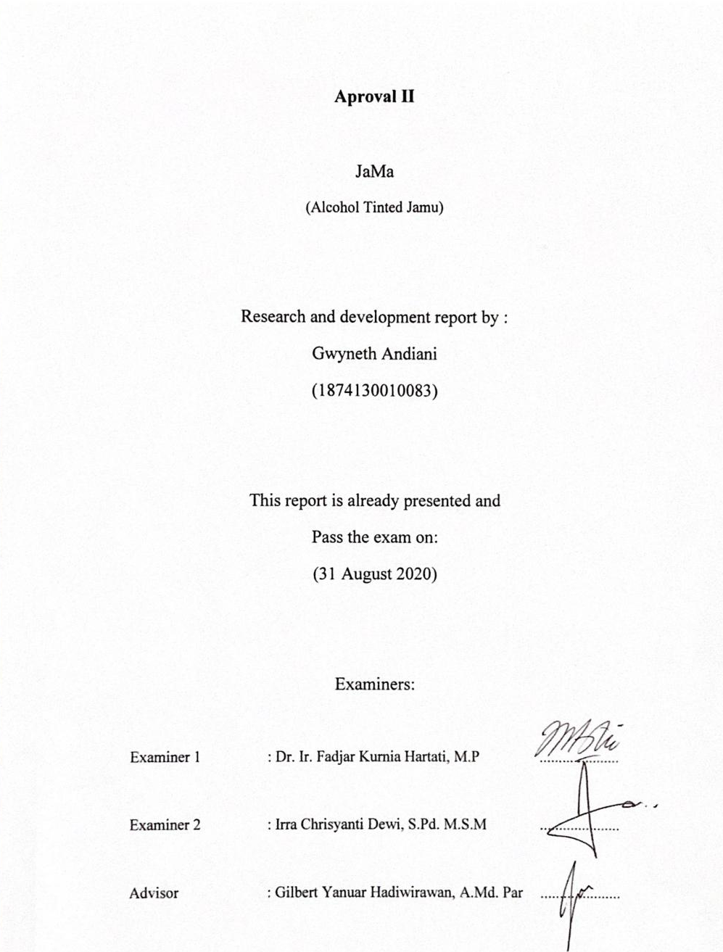

Aproval III

RESEARCH AND DEVELOPMENT PROJECT

Name : Gwyneth Andiani
Place, Date of Birth : Jakarta, 30 July 2000
N.I.M : 1874130010083
Study Program : D3 Culinary Arts
TITLE : JaMa (Alcohol tinted Jamu)

This paper is approved by:
Head of Culinary Arts Study Program, Advisor,
Date : 11 September 2020 Date : 11 September 2020

(Irra C. Dewi, S.Pd., M.S.M) (Gilbert Y. Hadiwirawan, A.Md. Par)
NIP. 19781201 1702 028 NIP. 19900101 1701 041

Director of
Akademi Kuliner dan Patiseri OTTIMMO Internasional
Date : 11 September 2020

(Zaldy Iskandar, B.Sc)
NIP. 19731025 1201 001
Plagiarism Statement
I can validate that this assignment and report are my own work, based on my personal study and/or research and that I have acknowledged all material and sourcesused in its preperation, whether they be books, articles, reports, lecture notes, and any other kind of documents, electronic or personal communication. I can also confirm that this assignment and report have not been submitted in any other unit for assessment, except where specific permission has been granted from all unit coordinators involved, or at any other time in this unit, and that I have not copied in parts or whole or otherwise plagiarised the work of other students and/or other people.
On this statement, I am ready to bear the risk and/or sanctions imposed to me in accordance with applicable regulations, if in future there is a breach of scientific ethics, or you have a claim against the authenticity of my work.

Surabaya, 11 September 2020
Author,

Gwyneth Andiani
Preface
This basis for this research originally stemmed frommy passion in developing and creating a new unique sensation in drinking jamu. As the world moves into the modern era, newer genereration gets distance from our traditional heritage. And how are we suppose to introduce this traditional heritage to our younger and modern generation? It is my determination to found a way to do that, by creating this product.
In truth, I could not have achieve this accomplishment without a support from other people. First of all my parents and sister, who supported me with love and understanding. And secondly, my suppervisor and friends, each of whom has provided patient advice and guidance throughout the research process. Thank you all for your unwavering support.

Table of Content
Title Page ........................................................................................... i
Aproval II ........................................................................................... ii
Aproval III ........................................................................................... iii
Plagiarism Statement ................................................................... iv
Preface ........................................................................................... v
Table of Content ............................................................................... vi
List of Tables ........................................................................................... ix
List of Figures ............................................................................... x
Executive Summary ............................................................................... xi
Chapter I Introduction ................................................................... 1
1.1 Background ............................................................................... 1
1.2 Objective ........................................................................................... 2
1.3 Benefit ........................................................................................... 2
1.3.1 For The Author .............................................................................. 2
1.3.2 For The Readers .............................................................................. 3
1.3.3 For OTTIMMO .............................................................................. 3
Chapter II Ingredients and Utensils Overview .............................. 4
2.1 The Materials to be Used ................................................................... 4
2.1.1 Alcohol ........................................................................................... 4
2.1.1.1 White Rice ............................................................................... 4
2.1.1.2 Tape Yeast ............................................................................... 5
2.1.2 Jamu ........................................................................................... 5
2.1.2.1 Rice Grains ............................................................................... 5
2.1.2.2 Kaempferia Galanga Kencur ....................................................... 5
2.1.2.3 Ginger ........................................................................................... 7
2.1.2.4 Javanese Sugar .................................................................. 8
2.1.2.5 Pandan Leaf ............................................................................. 9
2.1.2.6 Water .......................................................................................... 9
2.2 The Tools Used During the Process .......................................... 10
2.2.1 Container .............................................................................. 10
2.2.2 Plastic Wrap .............................................................................. 10
2.2.3 Digital Scale .............................................................................. 11
2.2.4 Spoon .......................................................................................... 11
2.2.5 Knife .......................................................................................... 12
2.2.6 Sauce Pan .............................................................................. 12
2.2.7 Blender .......................................................................................... 13
2.2.8 Glass Bottle .............................................................................. 13
2.2.9 Cheese Cloth .............................................................................. 14
Chapter III New Product Processing Sequence ............................... 15
3.1 The Processing Product ................................................................... 15
3.1.1 Alcohol ........................................................................................... 15
3.1.2 Jamu ........................................................................................... 17
3.1.2.1 Preparing the Ingredients ....................................................... 17
3.1.2.2 Blending the Ingredients ....................................................... 19
3.1.3 Combining Ingredients ................................................................... 19
3.2 Original Recipe ............................................................................... 20
3.3 Completed Recipe ............................................................................... 21
Chapter IV New Product Overview ........................................... 22
4.1 Nutrition Facts ............................................................................... 22
4.2 Comparison of Other Product ...................................................... 22
Chapter V Business Plan ................................................................... 24
5.1 CV ....................................................................................................... 24
5.2 Vision & Mission ............................................................................... 24
5.3 Business Scope ............................................................................... 25
5.4 Stakeholder ............................................................................... 26
5.5 SWOT Analysis ............................................................................... 27
5.5.1 Stregth ........................................................................................... 27
5.5.2 Weakness ............................................................................... 28
5.5.3 Opportunity ............................................................................... 28
5.5.4 Threath ........................................................................................... 29
5.6 Marketing Aspect ............................................................................... 29
5.6.1 Target Market ............................................................................... 30
5.6.2 Market Segmentation ................................................................... 30
5.6.2.1 Geographic ............................................................................... 30
5.6.2.2 Psychographic ....................................................... .................. 31
5.6.2.3 Demographic ....................................................... .................. 31
5.7 Financial Aspect ............................................................................... 31
5.7.1 Variable Cost ............................................................................... 31
5.7.2 Fixed Cost ............................................................................... 32
5.7.3 Overhead Cost ............................................................................... 32
5.7.4 Breakeven Point ................................................................... ....... 32
5.8 Technical Aspect ............................................................................... 34
5.9 Legal Aspect ............................................................................... 34
Chapter VI Conclusion ................................................................... 36
6.1 Conclusion ............................................................................... 36
6.2 Suggestion ........................................................................................... 36
BIBLIOGRAPHY ............................................................................... 38
APPENDIX ........................................................................................... 41

List of Tables
Table 1. Product Comparison ................................................................... 23
Table 2. Variable Cost ................................................................... 31
Table 3. Fixed Cost ............................................................................... 32
Table 4. Overhead Cost ................................................................... 32
Table 5. Breakeven Point ................................................................... 32

List of Figures
Figure 1. Yeast for Tape ................................................................... 5
Figure 2. Kencur for Jamu ................................................................... 6
Figure 3. Ginger for Jamu ................................................................... 7
Figure 4. Javanese Sugar for Jamu ....................................................... 8
Figure 5. Pandan Leaf for Jamu ....................................................... 9
Figure 6. Container ............................................................................... 10
Figure 7. Plastic Wrap ............................................................................... 10
Figure 8. Digital Scale ................................................................... 11
Figure 9. Spoon ............................................................................... 11
Figure 10. Knife ............................................................................... 12
Figure 11. Sauce Pan ............................................................................... 12
Figure 12. Blender ............................................................................... 13
Figure 13. Glass Bottle ................................................................... 13
Figure 14. Cheese Cloth ................................................................... 14
Figure 15. Crushed Yeast Tape ....................................................... 16
Figure 16. Mixing the Yeast with Rice ........................................... 16
Figure 17. Soaking & Toasting the Rice Grains ............................... 17
Figure 18. Diluting the Javanese Sugar ........................................... 18
Figure 19. Preparing the Aromatics ....................................................... 18
Figure 20. Blending the Jamu ................................................................... 19
Figure 21. Nutrition Facts ................................................................... 22
Figure 22. Sticker ............................................................................... 41
Figure 23. Packaging ............................................................................... 42
Figure 24. Product ............................................................................... 42

Executive Summary
This report is commisioned for a research and development program of OTTIMMO’s International students at the end of the second year. This reasearch and development program that we made is the idea how to encourage and to introduce traditional herbal drinks to young and modern generations. That is where the idea of JaMa comes from.
This product is made out of one of tthe most known traditional herbal drinks in Indonesia, called beras kencur. The jamu is then combined with one of Indonesia traditional snack called tape. We uses the alcohol that is produced by the tape to be mixed with the jamu, and that is what the product contain.
Though it does not have a lot of vitamins, it gives you a lot of benefits for your health. Known as a herbal drink to cure your cough, flu, and many more. So rest assure, because its benefits has been tested and proven by so many people.
Surely this product has its own strengths and weaknesses, and it is also compatible for children and elderly. This product needs time to produce, but with a little help we can atleast make 100 bottles per week, with the right tools. And surely if we wanted to make this business bigger, we need to apply a permit so we can comfortably sell this product all over Indonesia.
We are hoping that this product some day will be known to people around Indonesia, and people can enjoy the new sensation of drinking jamu. This product might need more research in the future to make it as perfect as it can be, but with the limited tools and the undergoing circumstances this product might not be as perfect as we are hoping it will be in the first place. And with feedbacks from the cunsomers it will also help us tremendously.

