RESEARCH AND DEVELOPMENT FINAL PROJECT
SMOKED LIDAH RICA
(Smoked Beef Tongue with Chili Pepper)
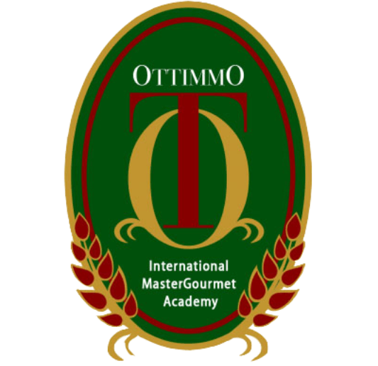

By
Gabrielle Jessica Witomo
1874130010037

STUDY PROGRAM OF CULINARY ART
OTTIMMO INTERNATIONAL MASTER GOURMET ACADEMY
SURABAYA
2020
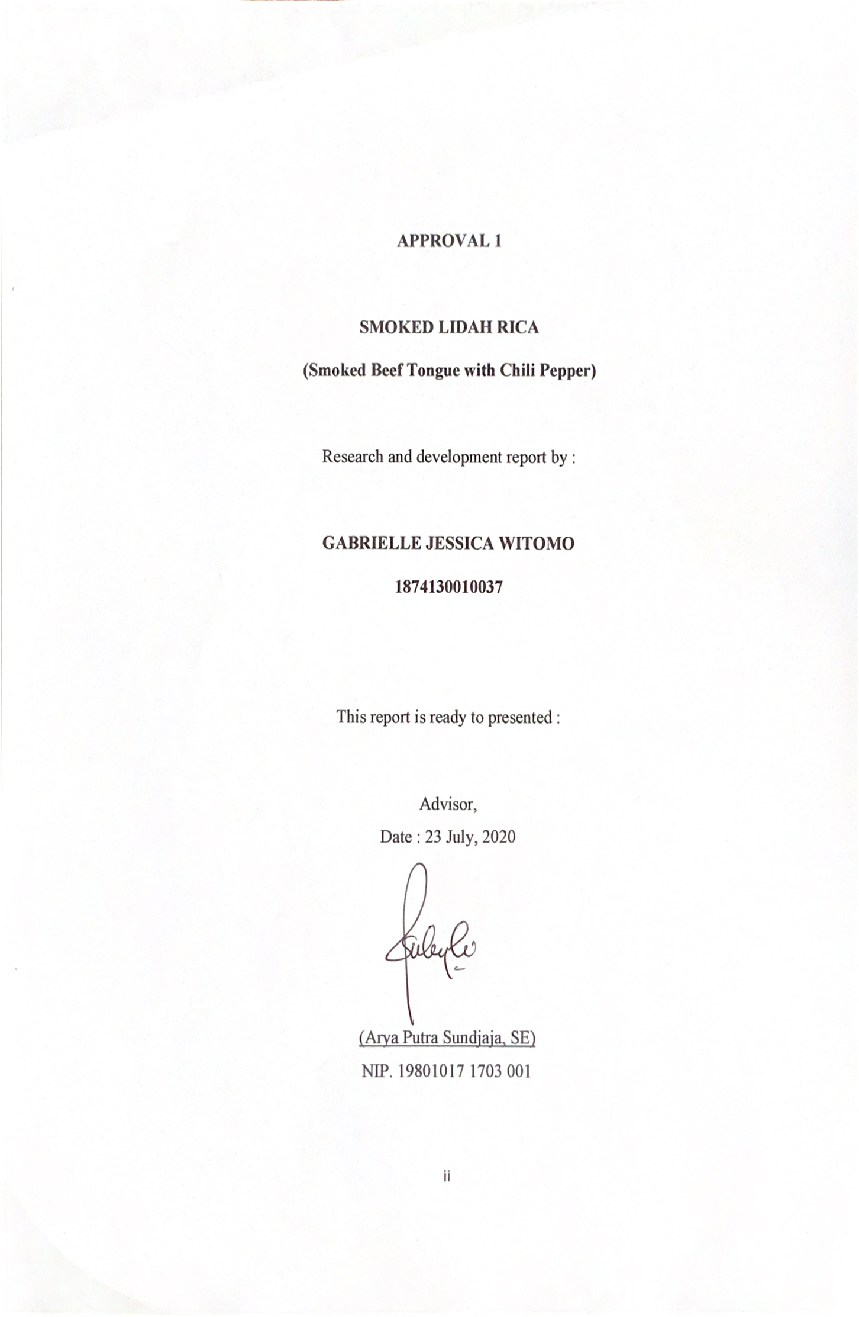
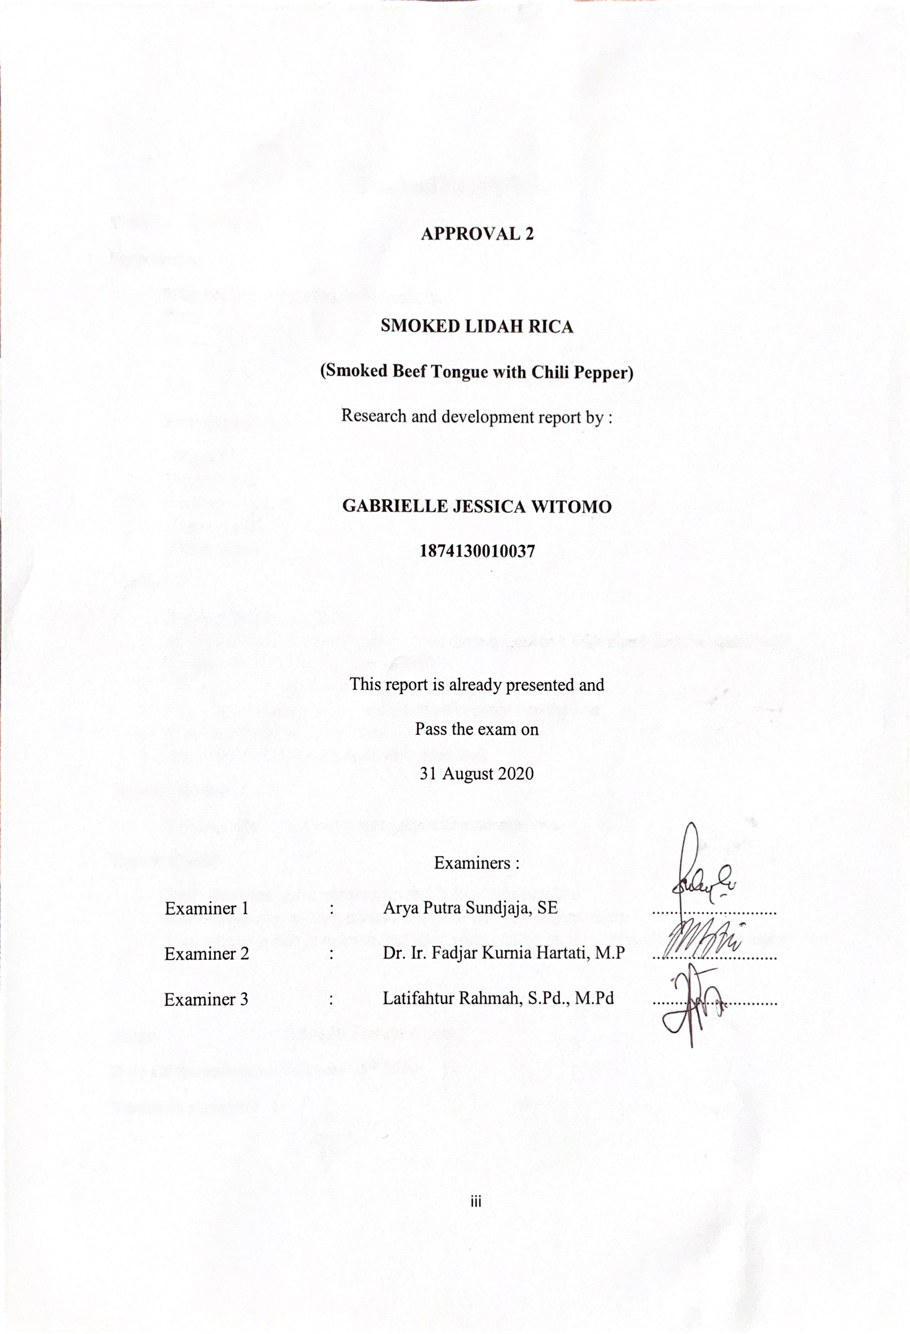
PLAGIARISM STATEMENT
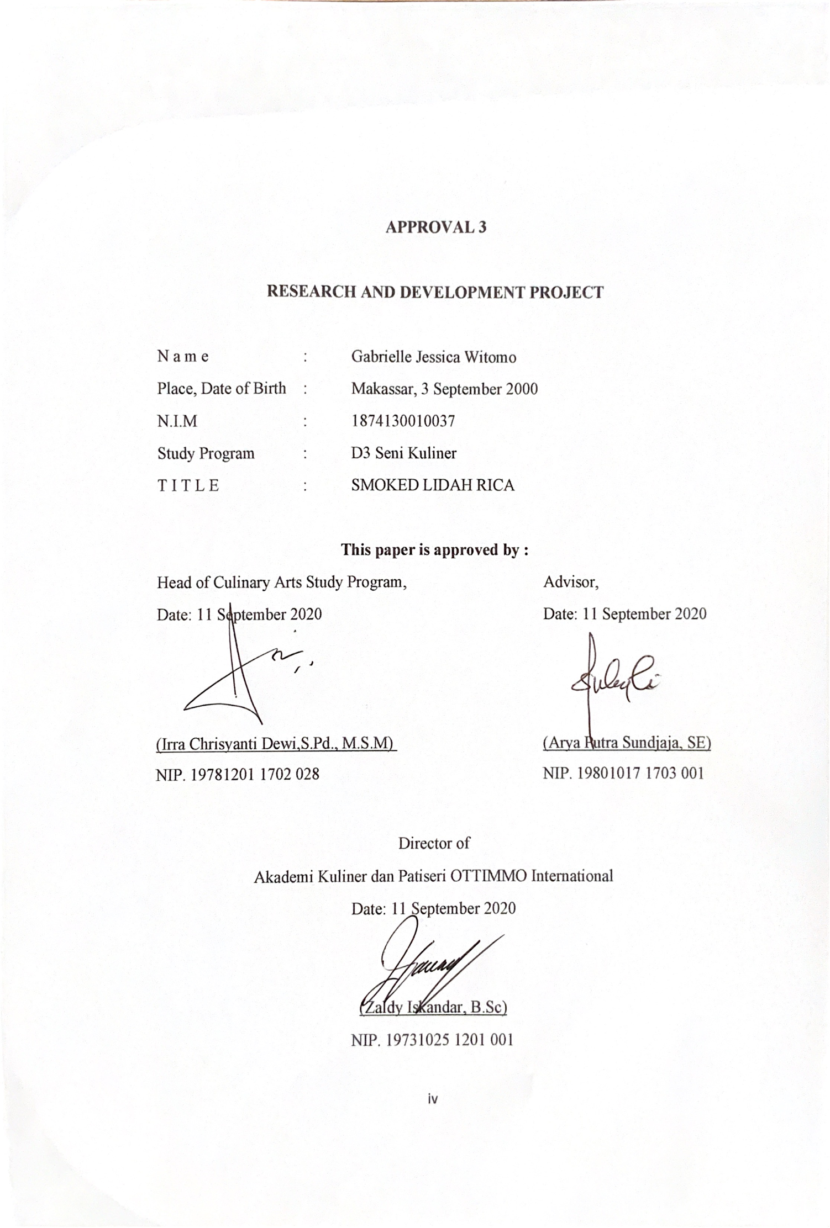
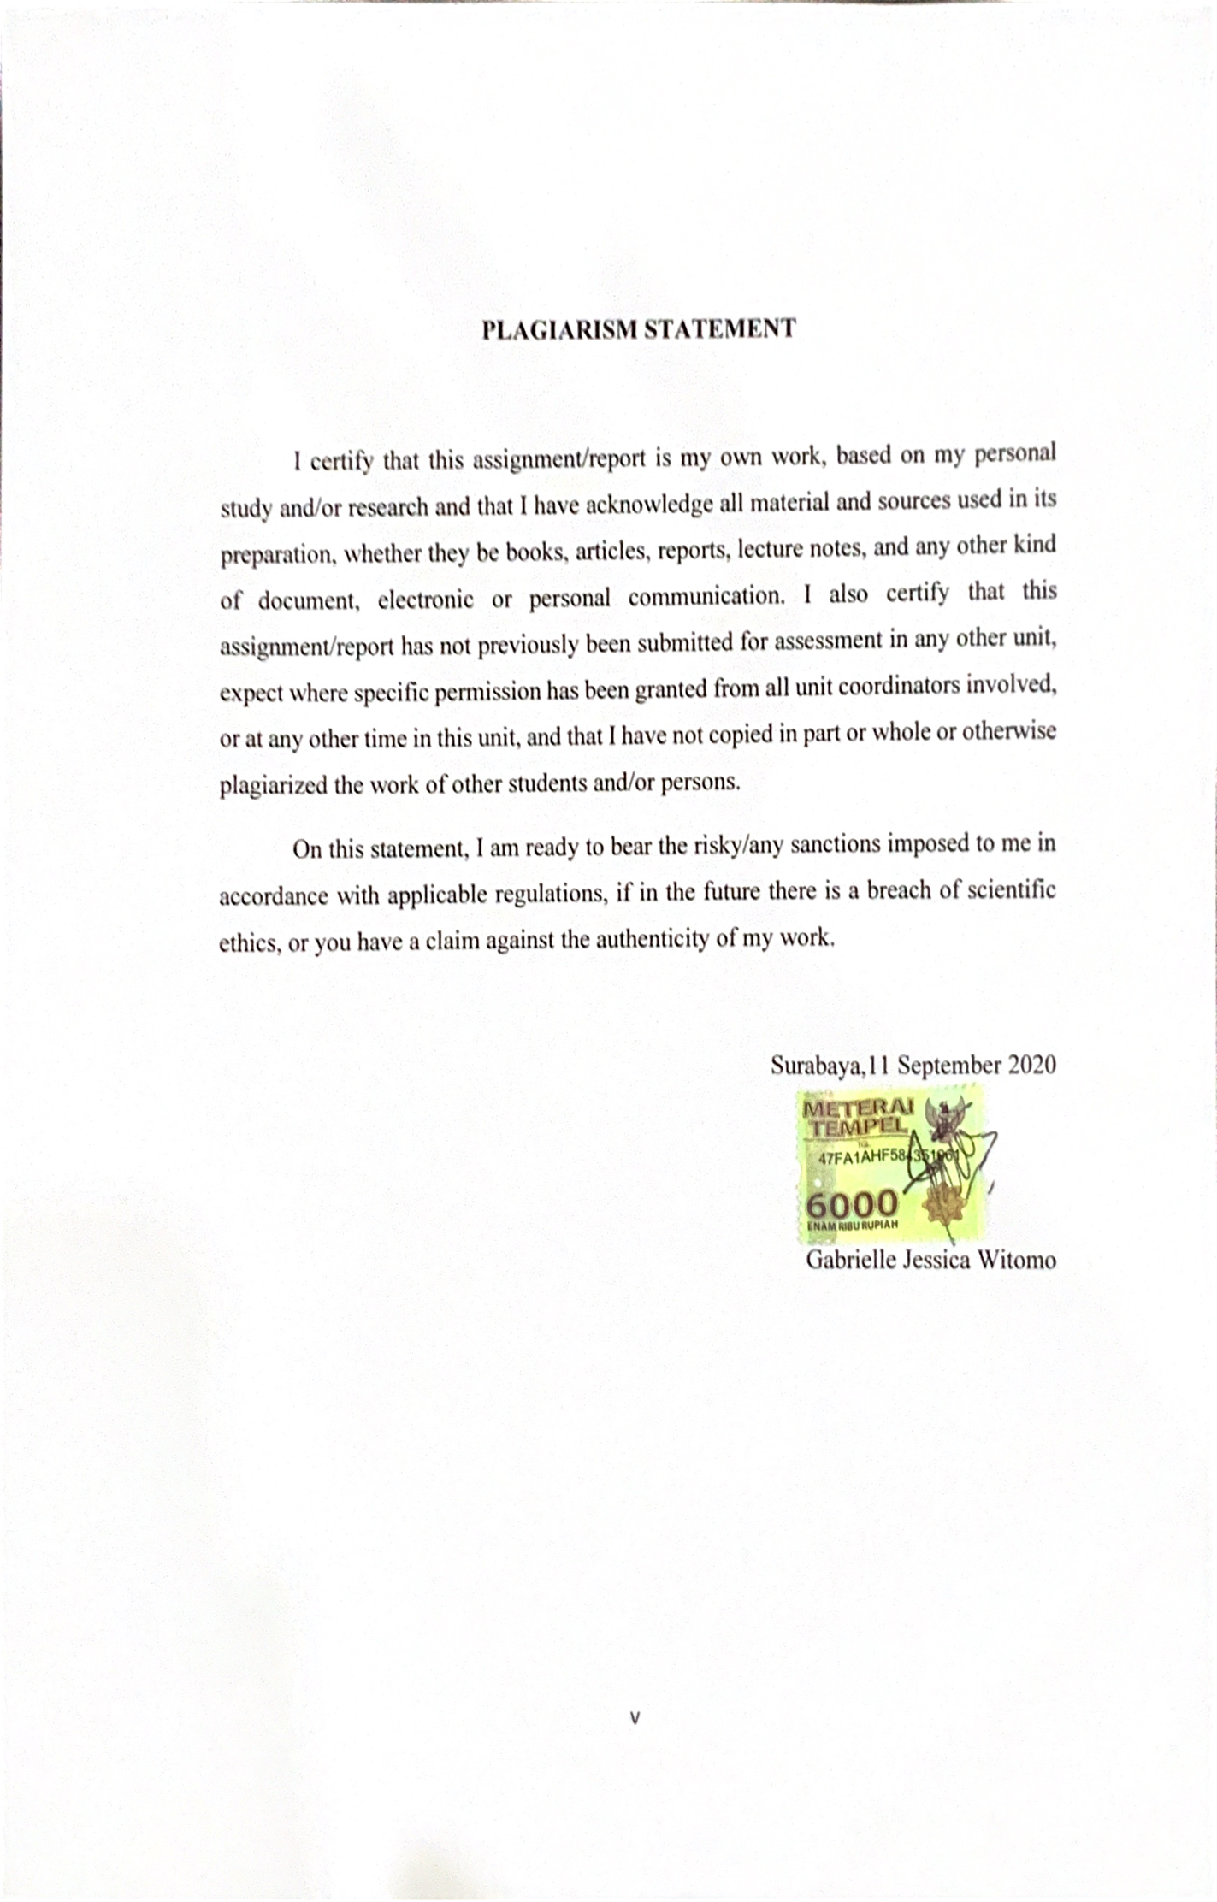
PREFACE
As for the beginning, i would like to thank my Holy God, Jesus Christ for his blessings for me to complete this Research and Development report. The main purpose for this report is to help each student in Ottimmo to be creative and innovative as we have to create a whole new product that never been in Indonesia. One of the reasons why i come up with the idea of making “Smoked Lidah Rica” is because i want people out there can taste a new things that have a good taste and also give some nutrients.
During this process of completing this report, i received so much guidance and support. By this, i would like to express my gratitute to the names below:
- Chef Zaldy Iskandar, Bsc as the Head Director of Ottimmo International
- Ms. Irra Dewi as the Head of Study Program at Ottimmo International
- Chef Arya Putra Sundjaja, SE as my RnD mentor who always help and supported me in many ways.
- My parents who have supported and provided me to achieve good education and as a family role to help me in personally.
- Ms. Sekar who help me to get many ideas and guide me to do this report
- My dearest friends, Ms. Olivia Gladys Setiawan and Mr. Michael Liemowa whohelp me by a lot of guidance and suggestions.

Surabaya,11 September 2020

Gabrielle Jessica Witomo
TABLE OF CONTENTS
TITTLE PAGE i
APPROVAL 1 ii
APPROVAL 2 iii
APPROVAL 3 iv
PLAGIARISM STATEMENT v
PREFACE vi
TABLE OF CONTENTS vii
LIST OF PICTURES viii
LIST OF TABLE xi
EXECUTIVE SUMMARY xii
CHAPTER I - INTRODUCTION 1
  - Background 1
  - Objectives 3
  - Benefits 3
CHAPTER II - INGREDIENTS AND UTENSILS OVERVIEW 4

  - Description of The Material to be Used 4
  - The Tools Used During The Process 9
CHAPTER III - NEW PRODUCT PROCESSING SEQUENCE 16
  - Procedure 16
  - Complete Recipe 25
CHAPTER IV - NEW PRODUCT OVERVIEW 28
CHAPTER V - BUSINESS PLAN 35

  - General Description 35
  - Scope Of Business 36
  - Description of Product 37
  - Stakeholder 38
  - Competitio Swot Analysis 40
  - Marketing Aspect 41
  - Financial Aspect 42
  - Technical Aspect 47
  - Legal Aspect 48
CHAPTER VI - CONCLUSION 49

  - Conclusion 49
  - Suggestion 49
BIBLIOGRAPHY 50
APPENDIX 51
- Packaging Design 51
- Supplier List 52
- Product Logo 52

LIST OF PICTURE
Picture 1. Raw Beef Tongue 4
Picture 2. Lime Leaf, Shallot, Garlic 5
Picture 3. Lemongrass 5
Picture 4. Cayenne Pepper 6
Picture 5. Red Chili Pepper 6
Picture 6. Salt, Chicken Powder 7
Picture 7. Granulated Sugar 7
Picture 8. Palm Oil 8
Picture 9. Wok 9
Picture 10. Chopper 9
Picture 11. Aluminium Foil 10
Picture 12. Stove 10
Picture 13. Pressure Cooker 11
Picture 14. Wooden Spatula 11
Picture 15. Bamboo Skewer 12
Picture 16. Plastic Sealer 12
Picture 17. Aluminium Sachet 13
Picture 18. Steamer Pot 13
Picture 19. Knife 13
Picture 20. Cutting Board 14
Picture 21. Scale 14
Picture 22. Plate 15
Picture 23. Clean Beef Tongue 17
Picture 24. Cook Beef Tongue with Pressure Cooker 17
Picture 25. After Cooked with Pressure Cooker 18
Picture 26. Sliced Beef Tongue 18
Picture 27. Shallot and Garlic 19
Picture 28. Cayenne Pepper and Red Chili Pepper 19
Picture 29. Wok with Oil 20
Picture 30. Shallot and Garlic 20
Picture 31. Chili, Lemongrass, Lime Leaf 20
Picture 32. Rica Sauce 21
Picture 33. Beef Tongue 21
Picture 34. Lidah Rica 21
Picture 35. Lidah Rica 22
Picture 36. Make Hole at Aluminium Foil 22
Picture 37. Steamer pot for Smoker 22
Picture 38. Lidah Rica at Steamer Pot 23
Picture 39. Cover with Lid 23
Picture 40. Smoking Process 23
Picture 41. Smoked Lidah Rica 23
Picture 42. Scale 24
Picture 43. Beef Tongue Nutrients 28
Picture 44. Cayenne pepper Nutrients 29
Picture 45. Red Chili Pepper Nutrients 30
Picture 46. Shallor Nutrients 31
Picture 47. Garlic Nutrients 32
Picture 48. Lemongrass Nutrients 33
Picture 49. Smoked Lidah Rica Nutrients 34
Picture 50. Smoked Lidah Rica Packaging 51
Picture 51. Product Logo 52
LIST OF TABLE
Table 1. Stakeholder 39
Table 2. SWOT Analysis 40
Table 3. Variable Cost 42
Table 4. Fixed Cost 44
Table 5. Overhead Cost 45
Table 6. Cost Of Production 45

EXECUTIVE SUMMARY
Smoked Lidah Rica is a product that has been made from beef tongue and chili pepper that already processed. Smoked Lidah Rica is a frozen food ready meal that can help people to eat easily. Smoked Lidah Rica have a spicy flavor.
There will be steps of processing. The first is cleaning the beef tounge with hot water, the second process is cook the beef tounge with pressure cooker until tender. The third is cook the beef tounge with spices. Next smoked the beef tounge with smoking agent. And the ast process is the packaging process
For one pack of Smoked Lidah Rica we can get 370 energy. Smoked Lidah Rica will be packed in a aluminium sachet. In each pack there will be 250g of Smoked Lidah Rica. For one pack will be sold for IDR 50.000

Keywords : smoked lidah rica, beef tongue.

