RESEARCH AND DEVELOPMENT FINAL PROJECT

Bured Wrap
(Burrito Edamame Wrap)

By:
Carlisshia Livia Gumono
187410030016

STUDY PROGRAM OF CULINARY ART
OTTIMMO INTERNASIONAL MASTERGOURMET ACADEMY
SURABAYA
2020

APPROVAL 1
Bured Wrap
(Burrito Edamame Wrap)

Research and development report by:
Carlisshia Livia Gumono)
1874130010016

This report is ready to presented :

Advisor,
Date:

(Latifahtur Rahmah, S.Pd., M.Kes)
Nip advisor :

(Irra C Dewi, S.Pd., M.S.M)
NIP. 19781201 1702 028

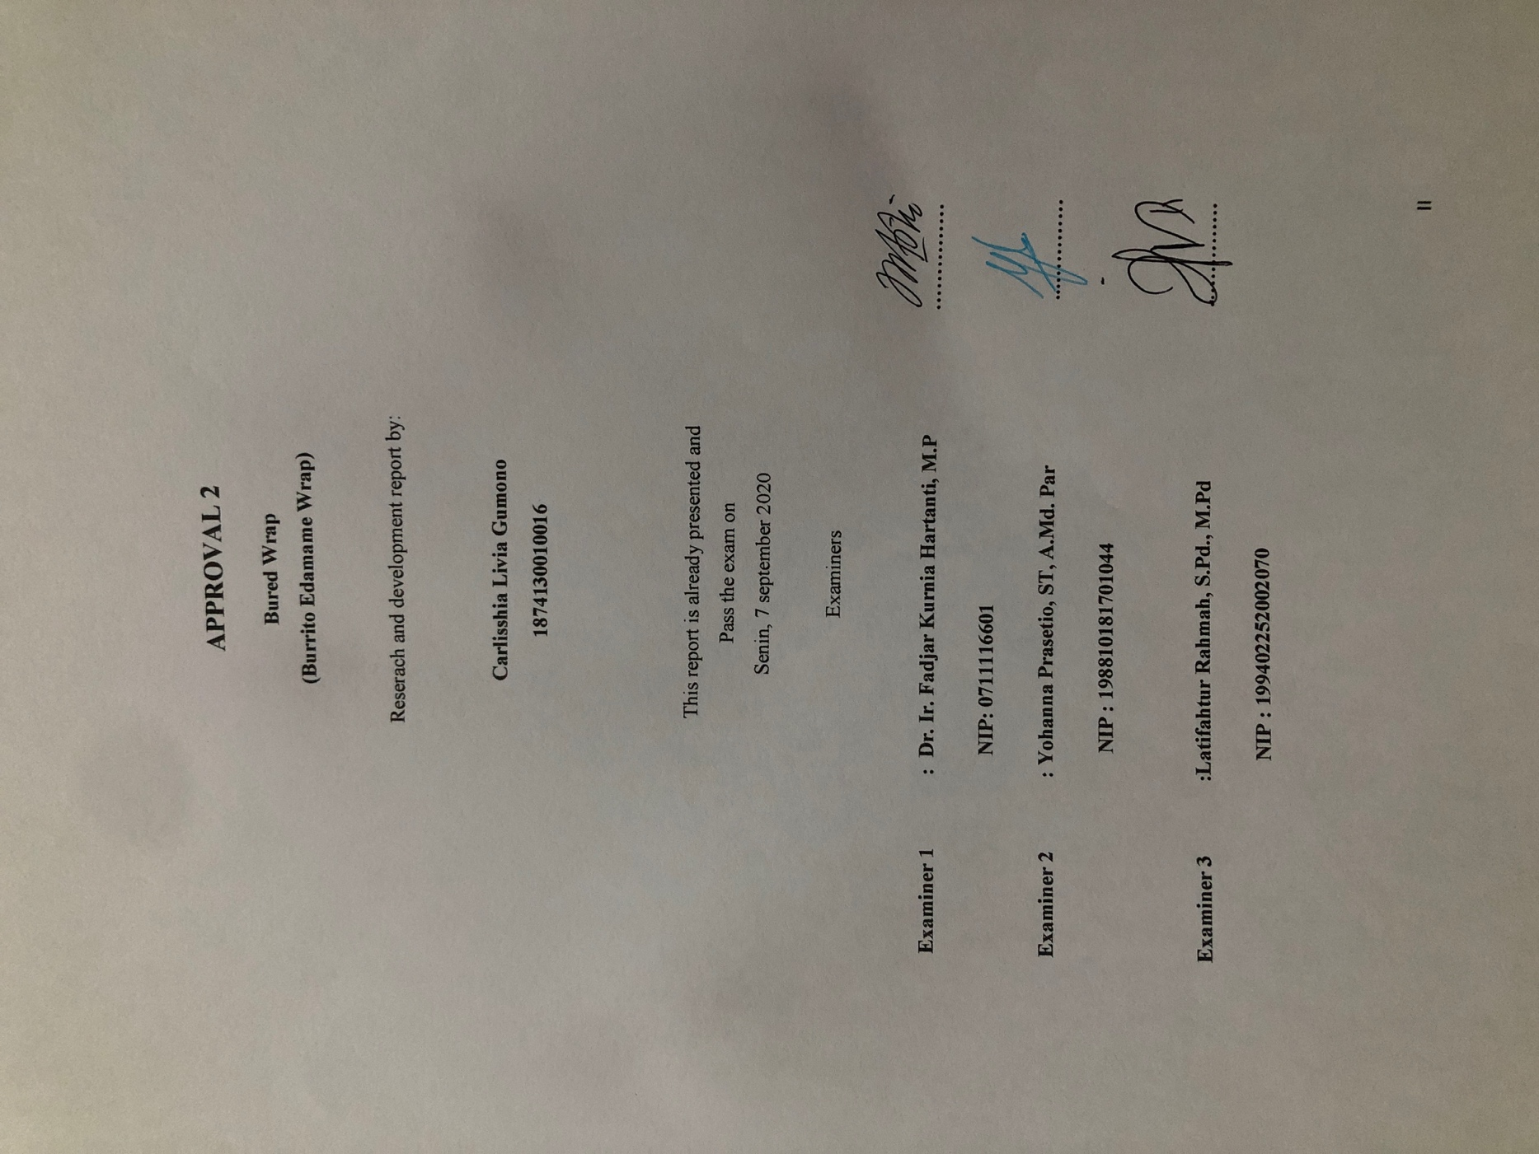

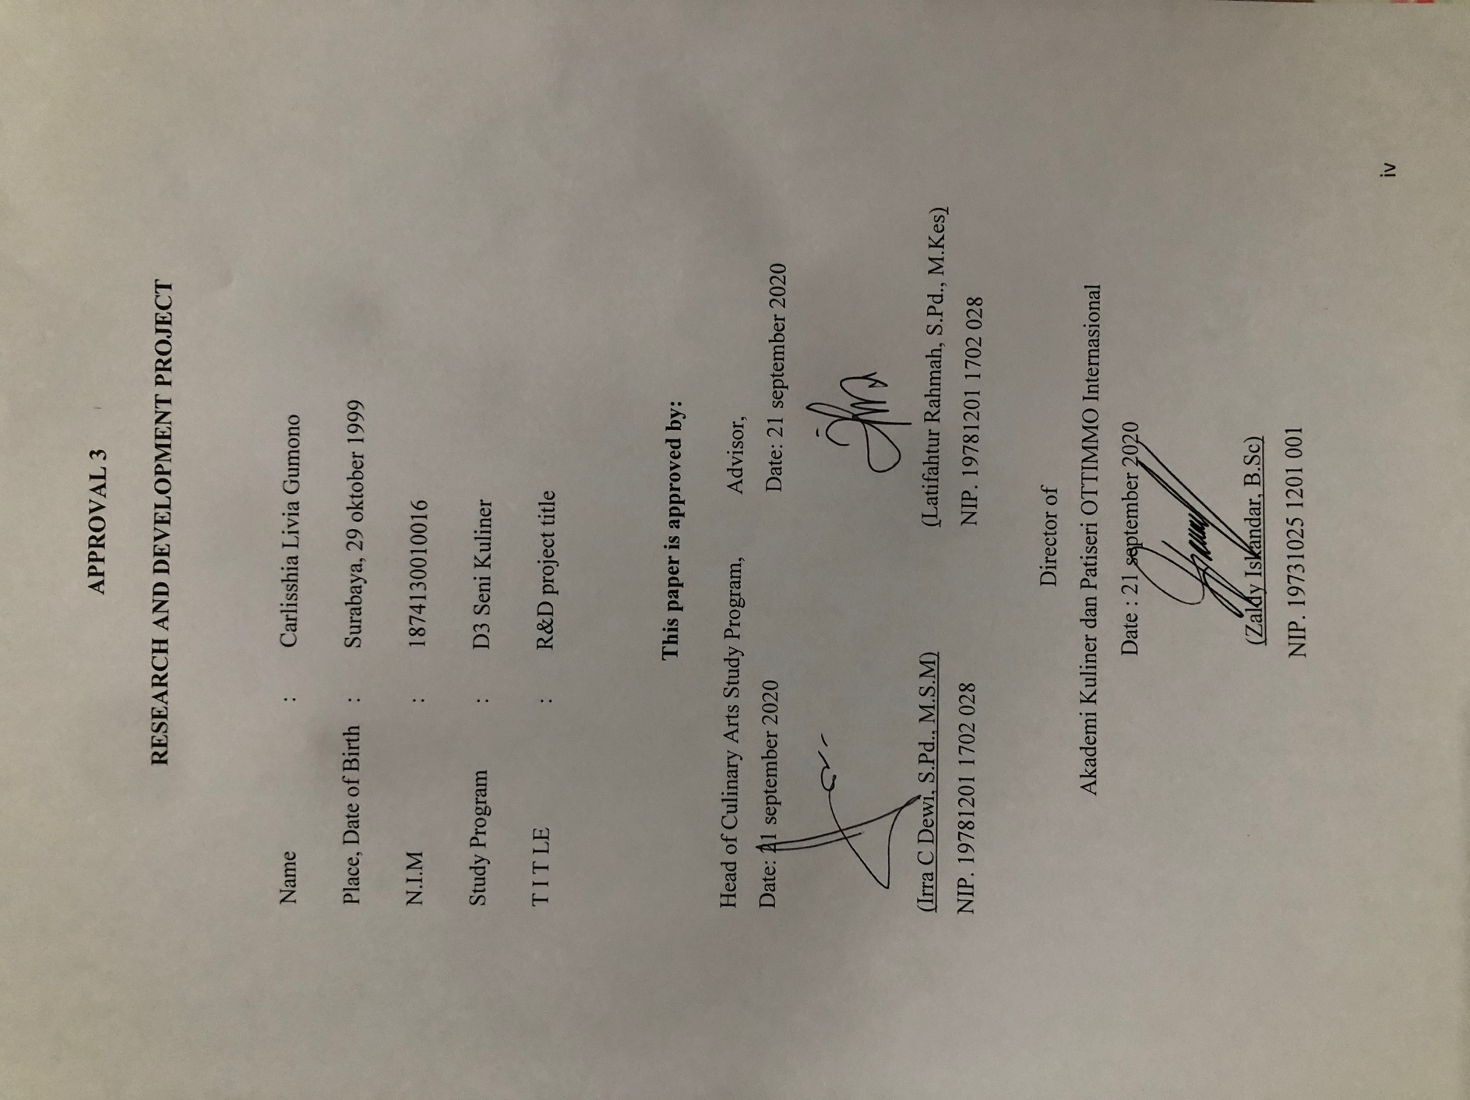
PLAGIARISM STATEMENT
I certify that this assignment/report is my own work, based on my personalstudy and/or research and that I have acknowledged all material and sourcesused in its preparation, whether they’re books, articles, reports, lecture notes,and any other kind of document, electronic or personal communication. I alsocertify that this assignment/report has not previously been submitted forassessment in any other unit, except where specific permission has been grantedfrom all unit coordinators involved, or at any other time in this unit, and that Ihave not copied in part or whole or otherwise plagiarised the work of other students and/or persons.

Surabaya, 6 March 2020
Carlisshia Livia Gumono
1874130010016

( Student Signature)
PREFACE
Thank to Almighty God who has given His bless to the author for finishing this final project RnD entitled “Bured Wrap (Buritto Edamame Wrap)”. I wrote this paper to fulfill one of the requirements in completing D3 education at Ottimmo Internasional.
The author has traveled a long journey in the context of completing the writing of this Final Project. Many obstacles faced in its preparation, but thanks to His will so that the author successfully completed the preparation of this thesis. Therefore, with full humility, on this occasion, the author should thank:
- To my parents who always gave love and support to the author.
- Thank you to Zaldy Iskandar, B.Sc as The Headmaster of Ottimmo International Mastergourmet Academy for providing the opportunity to conduct this research.
- Thank you to Latifahtur Rahmah, S.Pd, M.kes as Advisor for given his valuable, evaluations, comments, and suggestion during the completion and accomplishing of this research report.
- Thank you to Irra C. Dewi, S.pd, M.S.M, Ryan Yeremia Iskandar, Nurul Azizah C, S.TP., M.Sc, Latifahtur Rahmah, S.Pd, M.kes as examiners for contributed a lot of suggestion and criticism for the improvement of this research.
- And also thanks to all of our lecturers and staffs for knowledge, education and allowed me to do research.

Finally, the authors hope that this Final Project can provide benefits. The author also hopes that this thesis can be useful and that God Almighty provides protection for us all.
Surabaya, May 2020
Carlisshia Livia Gumoo
TABLE OF CONTENT
(POINT)
APPROVAL …..................................................................................... II
PLAGIARISM STATEMENT .............................................................. VI
PREFACE .................…......................................................................... V
TABLE OF CONTENT ....................…................................................. VIII
EXECUTIVE SUMMARY ..............…................................................. X
LIST OF PICTURES ……......….......................................................... XI
LIST OF TABLE ….............…............................................................. XII
CHAPTER I INTRODUCTION .................................................... 1
  - BACKGROUND STUDY ........................................ 1
  - THE OBJECTIVES STUDY ..................................... 4
  - THE BENEFITS STUDY ......................................... 4
CHAPTER II INGREDIENTS AND UTENSILS OVERVIEW …...... 5
- DESCRIPTION MATERIAL TO BE USED ............ 5
- THE TOOLS USED DURING THE PROSECCING
..................................................................................... 7
CHAPTER III NEW PRODUCT PROCESSING SEQUENCE …....... 9
- THE PROCESSING PRODUCT BY USING POCTIRE
..................................................................................... 9
- THE PROCESSING PRODUCT .............................. 10
- COMPLETE RECIPE ATTACHED .......................... 12
CHAPTER IV NEW PRODUCT OVERVIEW .................................... 13
- THE FACT OF NUTRITION (INGREDIENTS) ....... 13
- THE FACT OF NUTRITION (PRODUCT)............... 13
CHAPTER V BUSINESS PLAN …................................................... 15
- GENERAL DESCRIPTION COMPANY ................ 15
- BUSINESS SCOPE .................................................. 16
- STAKEHOLDER ................................................... 17
- SWOT ANALYSIS .................................................. 23
- MARKETING ASPECT ........................................... 25
- FINANCIAL ASPECT ............................................. 26
- TECHNICAL ASPECT ............................................ 34
- LEGAL ASPECT ..................................................... 35
CHAPTER VI CONCLUSION ............................................................ 40
- CONCLUSION ........................................................... 40
- SUGGESTION ............................................................ 40
BILIOGRAPHY ................................................................................... . 41
APPENDIX ........................................................................................... 42
APPENDIX 1. PACKAGING DESIGN .......................... 42
APPENDIX 2. LIST OF MAIN INGREDIENTS SUPPLIER, SUPPORTER AND PACKAGING .............. 43
APPENDIX 3. LOGO PICTURES, PRODUCT (BEFORE AND AFTER SELLING ......................................... 44
APPENDIX 4. RECIPE ATTACHED .............................. 45

EXECUTIVE SUMMARY
Food is a need that is used by everyone in fulfilling substances in the body. To replenish nutrients, prevent disease, and meet food needs. Therefore, it is important to always maintain the nutrients we consume every day.

At present, there are many products that can be made edamame. for example edamame milk, edamame cookies etc. That's why we do this research and development, we will provide innovations for new types of products from edamame products that are not yet on the market.

For people who are aware of health, good food is not necessarily healthy. The most fatal is disrupting their digestion, health and body shape. They will choose wisely which foods contain better nutrition, for example they will choose low-fat foods.

By seeing this opportunity, we took the innovation to make edamame torttila in the category of vegan, allergic sufferers and people who have awareness of healthy food.
LIST OF PICTURES
Picture 1. Ingredients of Bured Wrap .................................................. 5
Picture 2. Tools of Bured Wrap ........................................................... 7
Picture 3. Smoothes the crispy edamame ............................................. 10
Picture 4. Edamame flour ..................................................................... 10
Picture 5. Edamame flour and pastry flour (cakra kembar) ................. 10
Picture 6. All ingredient ........................................................................ 10
Picture 7. Mixing all ingredient ............................................................ 10
Picture 8. Cut the dough in to 60g to 15 pcs ......................................... 11
Picture 9. Roll the dough ...................................................................... 11
Picture 10. Toast the tortilla .................................................................. 11
Picture 11. Bured wrap (Burrito Edamame Wrap) ................................ 11
Picture 12. Nutrition fact of Bured Wrap .............................................. 14
Picture 13. Product packaging ............................................................... 19
Picture 14. Smoothes the crispy edamame ............................................ 20
Picture 15. Edamame flour .................................................................... 20
Picture 16. Mix edamame flour and pastry flour ................................... 21
Picture 17. Mix all the ingredients became the tortilla dough ................ 21
Picture 18. Cut the dough in 60g to15 pcs ............................................ 21
Picture 19. Roll the tortilla dough ......................................................... 21
Picture 20. Toast the dough briefly to teflon pan ................................... 22
Picture 21. Put the tortilla dough in the freezer ..................................... 22
Picture 22. Product packaging ............................................................... 22
Picture 23. Design packaging ................................................................ 42
Picture 24. Logo picture ........................................................................ 44
Picture 25. Product before packaging ................................................... 44
Picture 26. Product after packaging ...................................................... 45
Picture 27. Recipe attached ................................................................... 46

LIST OF TABLE

Table 1. Nutrition facts of ingredient ................................................. 13
Table 2. Cooking process .................................................................... 20
Table 3. Consumer characteristic ........................................................ 25
Table 4. Fariabel cost in food cost ...................................................... 26
Table 5. Variable cost B ...................................................................... 27
Table 6. Fixed cost with depreciation cost .......................................... 27
Table 7. Product benefit analisis ......................................................... 31

