RESEARCH AND DEVELOPMENT FINAL PROJECT

WOKU TOFU
(HEALTHY TOFU WITH MANADO FLAVOR)

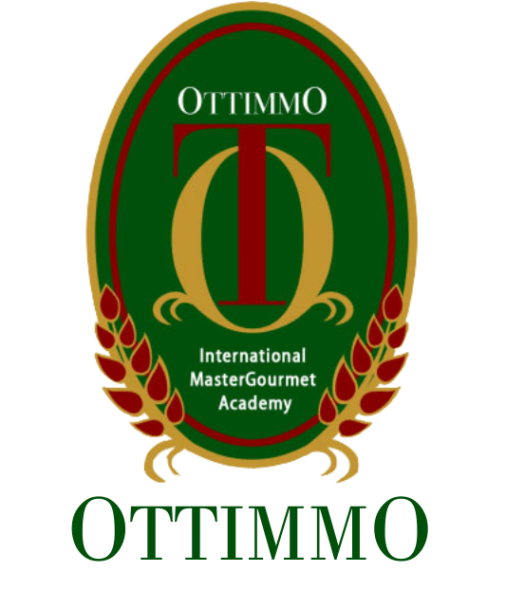

By
ANGELINA SUHERMAN
1874130010072

STUDY PROGRAM OF CULINARY ART OTTIMMO INTERNATIONAL MASTERGOURMET ACADEMY
SURABAYA
2020

RESEARCH AND DEVELOPMENT FINAL PROJECT
WOKU TOFU
(HEALTHY TOFU WITH MANADO FLAVOR)

By
ANGELINA SUHERMAN
1874130010072

STUDY PROGRAM OF CULINARY ART OTTIMMO INTERNATIONAL MASTERGOURMET ACADEMY
SURABAYA
2020

