CHAPTER II
INGREDIENTS OVERVIEW

2.1 Moringa ( Moringa oleifera L)
Moringa also known as Moringa oleifera is popular in tropical and subtropical areas. Until now, this tree is used for traditional medicine by Indonesian people.
2.1.1 Definition of Moringa
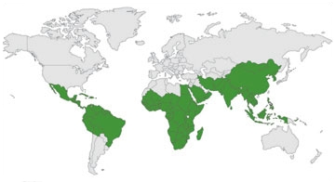
Moringa oleifera is a small native tree of the sub-Himalayan regions of North West India, which is now indigenous to many regions in Africa, Arabia, South East India, The Pacific and Caribbean Island and South America Islands and South America. The other terms used for Moringa are Horseradish tree, Mulangay, Mlonge, Benzolive, Drumstick tree, Sajna, Kelor, Saijihan and Marango.
Picture 1 Countries where Moringa grows (treesforlife.org, 2011)

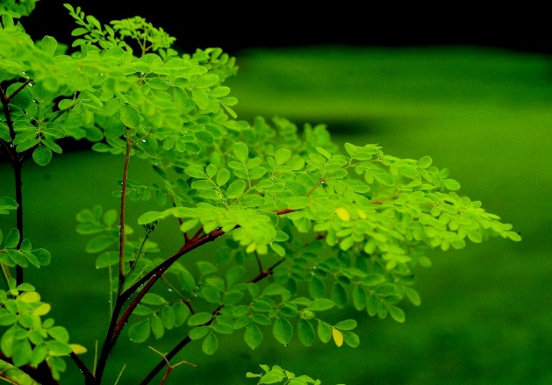
2.2.2 Morphology of Moringa Trees
Moringa oleifera is a small, graceful, deciduous tree with sparse foliage, often resembling a leguminous species at a distance, especially when in flower, but immediately recognized when in fruit. This tree can grow to 8m high and 60cm dbh. Bark smooth, dark grey, slash thin, yellowish. Twigs and shoots shortly but densely hairy. Crown wide, open, typically umbrella shaped and usually a single stem; often deep rooted. The wood is also smooth ( Orwa et al., 2019).
Picture 2.Moringa oleifera tree (oilseedcrops.org, 2019)

2.1.3 Taxonomic Classification of Moringa Trees (H., Ganatra Tejas, 2012) `
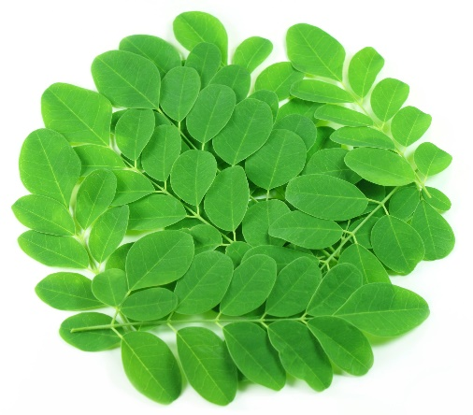
Kingdom : Plantae
Sub kingdom : Tracheobionta
Super Division : Spermatophyta
Division : Magnoliophyta
Class : Magnoliopsida
Subclass : Dilleniidae
Order : Capparales
Family : Moringaceae
Genus : Moringa
Picture 3 Moringa oleifera leaves
Species : oleifera

2.1.4 Nutrients contents of mature Moringa oleifera (100 grams fresh weight) :
Table 1 Nutrients composition of Moringa leaves, seeds and pods.
Nutrients | Fresh leaves | Dry Leaves | Leaf powder | Seeds | Pods
Calories (cal) | 92 | 329 | 205 | - | 26
Protein (g) | 6.7 | 29.4 | 27.1 | 35.97 $±$ 0.19 | 2.5
Fat (g) | 1.7 | 5.2 | 2.3 | 38.67 $±$ 0.03 | 0.1
Carbohydrate (g) | 12.5 | 41.2 | 38.2 | 8.67 $±$ 0.12 | 3.7
Fiber (g) | 0.9 | 12.5 | 19.2 | 2.87 $±$ 0.03 | 4.8
Vitamin B1 (mg) | 0.06 | 2.02 | 2.64 | 0.05 | 0.05
Vitamin B2 (mg) | 0.05 | 21.3 | 20.5 | 0.06 | 0.07
Vitamin B3 (mg) | 0.8 | 7.6 | 8.2 | 0.2 | 0.2
Vitamin C (mg) | 220 | 15.8 | 17.3 | 4.5 $±$ 0.1 7 | 120
Vitamin E (mg) | 448 | 10.8 | 113 | 751.67 $±$ 4.41 | -
Calcium (mg) | 440 | 2185 | 2003 | 45 | 30
Magnesium (mg) | 42 | 448 | 368 | $635±$ 8.66 | 24
Phosphorus (mg) | 70 | 252 | 204 | 75 | 110
Potassium (mg) | 259 | 1236 | 1324 | - | 259
Copper (mg) | 0.07 | 0.49 | 0.57 | 5.20 $±$ 0.15 | 3.1
Iron (mg) | 0.85 | 25.6 | 28.2 | - | 5.3
Sulphur (mg) | - | - | 870 | 0.05 | 137
(L. Gopalakrishnan et al., 2016)

Moringa leaves has a rich source of antioxidants, including beta carotene, vitamin C, quercetin, and chlorogenic acid. It has been found that chlorogenic acid can lower the sugar blood levels (Paikra, et.al, 2017). So, diabetics people can consume Moringa leaves. Moringa leaves also contains essential amino acids to build strong healthy bodies and contains a high level of fibre. It makes Moringa can clean up any grunge left from the last greasy diet and have anti-bacterial activity that may help to rid our body of H.pylori, bacteria implicated in gastritis ulcers and gastric cancer ( Paikra, 2017). From that, we can know that Moringa leaves are very high in nutrients, antioxidants and low in oxalate.

2.2 Almond ( Prunus dulcis)
Almond, (Prunus dulcis), tree native to southwestern Asia and its edible seed. A member of the family Rosaceae (order Rosales), Prunus dulcis is an economically important crop tree grown primarily in Mediterranean climates between 28° and 48° N and between 20° and 40° S, with California producing nearly 80 percent of the world’s supply (Petruzzello, 2019).
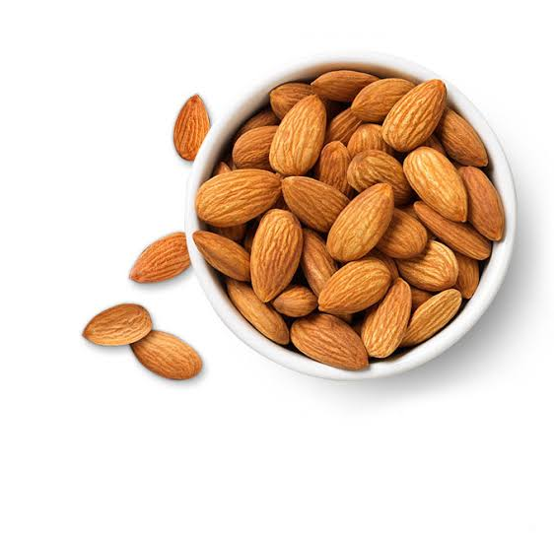
2.2.1 Definition of Almond
Almond ( Prunus dulcis) is a type of nuts that easily to be found in Indonesia also has low-medium price. Almond consist four portions: kernel or meat, middle shell, outer green shell cover or almond hull and a thin leathery layer known as brown skin of meat or seedcoat. Almond contains high levels of monounsaturated and polyunsaturated fatty acids, protein and dietary fibre, as well as a variety of essential nutrients including vitamin E and several trace elements ( Richardson et.al, 2009). Since almond contains many healthy nutrients, it can reduce cholesterol level or other heart disease risk factors and also have positive role in healthy weight maintenance and weight loss.
Picture 4 Almonds (google picture.com, 2019).

2.2.2 Morphology of Almond
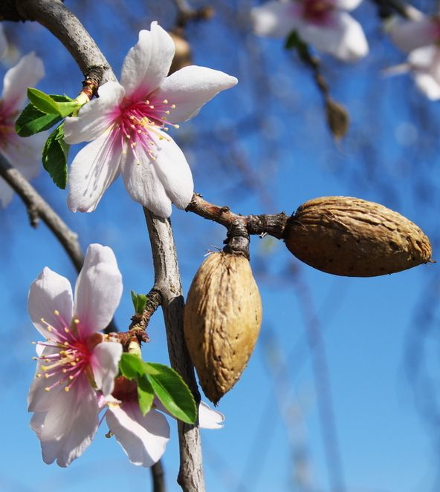
Almond trees are deciduous with a hardy dormancy. Typically growing 3–4.5 metres (10–15 feet) tall, the trees are strikingly beautiful when in flower; they produce fragrant, five-petaled, light pink to white flowers from late January to early April north of the Equator. The flowers are self-incompatible and thus require insect pollinators to facilitate cross-pollination with other cultivars. The growing fruit (a drupe) resembles a peach until it approaches maturity; as it ripens, the leathery outer covering, or hull, splits open, curls outward, and discharges the pit. Despite their common label, almonds are not true nuts (a type of dry fruit) but rather seeds enclosed in a hard fruit covering (Petruzzello, 2019).
Picture 5 Almond Tree, Pinterest.com.au

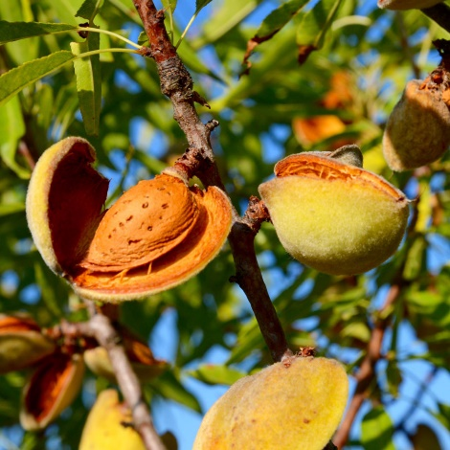
2.2.3 Taxonomic Classification of Almond
Kingdom : Plantae
Clade : Angiosperms
Clade : Eudicots
Clade : Rosids
Order : Rosales
Family : Rosaceae
Genus : Prunus
Subgenus : Prunus subg. Amygdalus
Picture 6 Almond Tree, hotelroomsearch.net
Species : P. dulcis

2.2.4 Nutrients contents of mature Almond
Table 2 Nutrients (Proximates) of 100 grams Almond
Nutrients  (per 100g) | units | Natural | blanched | Oil roasted salted |  | Oil roasted unsalted | Dry roasted salted | Dry roasted unsalted
Calories | kcal | 579 | 590 | 607 | 607 |  | 598 | 598
Water | g | 4.41 | 4.51 | 2.80 | 2.80 |  | 2.41 | 2.41
Protein | g | 21.15 | 21.40 | 21.23 | 21.23 |  | 20.96 | 20.96
Lipids (total) | g | 49.93 | 52.52 | 55.17 | 55.17 |  | 52.54 | 52.54
Dietary Fiber (Total) | g | 12.5 | 9.9 | 10.5 | 10.5 |  | 10.9 | 10.9
Sugars (Total) | g | 4.35 | 4.63 | 4.55 | 4.55 |  | 4.86 | 4.86
Ash | g | 2.97 | 2.91 | 3.13 | 3.13 |  | 3.07 | 3.07
(US Department of Agriculture, 2015).

Table 3 Nutrients (Minerals) of 100 grams Almond
Nutrients  (per 100g) | Un-its | Natural | blanched | Oil roasted salted |  | Oil roasted unsalted | Dry roasted salted | Dry roasted unsalted
Calcium (Ca) | mg | 269 | 236 | 291 | 291 |  | 268 | 268
Iron (Fe) | mg | 3.71 | 3.28 | 3.68 | 3.68 |  | 3.73 | 3.73
Magnesium (Mg) | mg | 270 | 268 | 274 | 274 |  | 279 | 279
Phosphorus (P) | mg | 481 | 481 | 466 | 466 |  | 471 | 471
Potassium (K) | mg | 733 | 659 | 699 | 699 |  | 713 | 713
Sodium (Na) | mg | 1 | 19 | 339 | 1 |  | 498 | 3
Zinc (Zn) | mg | 3.12 | 2.97 | 3.07 | 3.07 |  | 3.31 | 3.31
Copper (Cu) | mg | 1.03 | 1.03 | 0.96 | 0.96 |  | 1.10 | 1.10
Manganese (Mn) | mg | 2.18 | 1.84 | 2.46 | 2.46 |  | 2.23 | 2.23
(US Department of Agriculture, 2015).

Table 4 Nutrients (Vitamins) of 100 grams Almond
Nutrients  (per 100g) | Un-its | Natural | blanched | Oil roasted salted |  | Oil roasted unsalted | Dry roasted salted | Dry roasted unsalted
Vitamin E | mg | 25.63 | 23.75 | 25.97 | 25.97 |  | 23.90 | 23.90
Thiamin | mg | 0.21 | 0.19 | 0.09 | 0.09 |  | 0.08 | 0.08
Riboflavin | mg | 1.14 | 0.71 | 0.78 | 0.78 |  | 1.20 | 1.20
Niacin | mg | 3.62 | 3.50 | 3.67 | 3.67 |  | 3.64 | 3.64
Pantothenic Acid | mg | 0.47 | 0.31 | 0.23 | 0.23 |  | 0.32 | 0.32
Vitamin B6 | mg | 0.14 | 0.12 | 0.12 | 0.12 |  | 0.14 | 0.14
Folate Food | mcg | 44 | 49 | 27 | 27 |  | 55 | 55
(US Department of Agriculture, 2015).

Table 5 Nutrients (Fatty Acids) of 100 grams Almond
Nutrients  (per 100g) | Un-its | Natural | blanched | Oil roasted salted |  | Oil roasted unsalted | Dry roasted salted | Dry roasted unsalted
Saturated (Total) | g | 3.80 | 3.95 | 4.21 | 4.21 |  | 4.09 | 4.09
Monounsaturated (Total) | g | 31.55 | 33.42 | 34.79 | 34.79 |  | 33.08 | 33.08
Polyunsaturated (Total) | g | 12.33 | 12.37 | 13.52 | 13.52 |  | 12.96 | 279
(US Department of Agriculture, 2015).

2.3 Sugar Alcohol
Sugar alcohol is a sugar commonly found in food such as erythritol, sorbitol, mannitol, xylitol, isomalt and hydrogenated starch hydrolysates. In this research, researcher will use erythritol. Erythritol ((2R,3S)-butane-1,2,3,4-tetraol) is a sugar
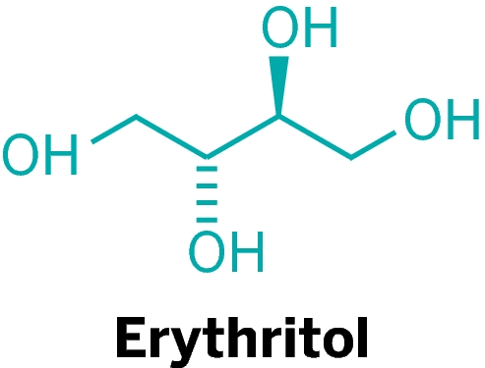
alcohol commonly used in most countries. This sugar alcohol was found by Scottish chemist, John Stenhouse. It occurs naturally in some fruit and fermented foods (Godswill, 2017). In human body, erythritol is absorbed into the bloodstream inside the small intestine, and then the most
Picture 7 Eryhtritol (Anonymous, 2019)
part excreted unchanged in the urine. About 10% of erythritol enters the colon because 90% of erythritol is absorbed before it enters the large intestine (Godswill, 2017). Erythritol can be used as healthy dietary sugar because it is low in calories than other sugar alcohols. With only 6% of the calories of sugar, it still contains 70% of the sweetness. Human studies show very few side effects, mainly minor digestive issues in some people, but overall compared to another sugar, this product the most healthier. According to Godswill, erythritol also safe for diabetics because more than 90% of ingested erythritol isn’t metabolized by the human body and is excreted unchanged in the urine without changing blood glucose and insulin levels.

Table 6 Nutrients of 100 grams Sugar Alcohol
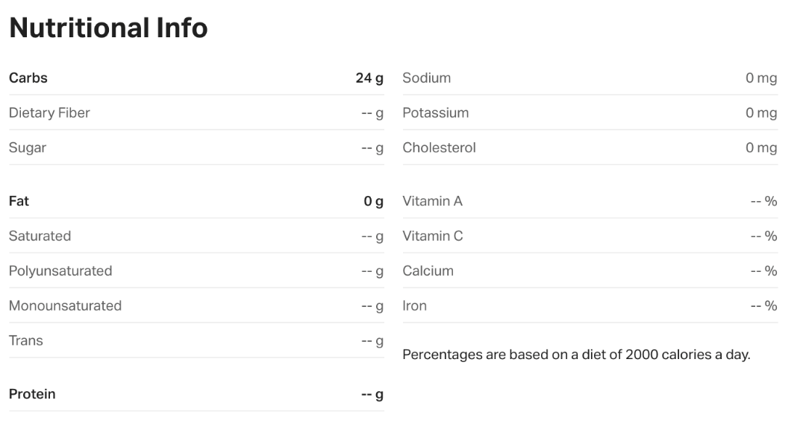

2.4 Soy Milk
Soy milk is healthful options in various ways. They contain different nutrients and may have varying benefits for people's health. Soy milk has a higher content of monounsaturated and polyunsaturated fats compared with saturated fats. Saturated fats, which are in cow's milk, contribute to high cholesterol and heart problems. Along with containing healthful fats, soy milk is the only dairy alternative that offers a similar amount of protein as cow's milk. The nutrient content in soy milk is comparable to that of cow's milk. Apart from its naturally cholesterol free and vegan properties, soy milk contains isoflavones. Research suggests that isoflavones are antioxidants, can reduce inflammation in the body, and may also have anticancer effects. According to the National Center for Complementary and Integrative Health, consuming soy protein each day may reduce LDL cholesterol.

Table 7 Nutrients of 100 ml Soy Milk
