APPENDIX

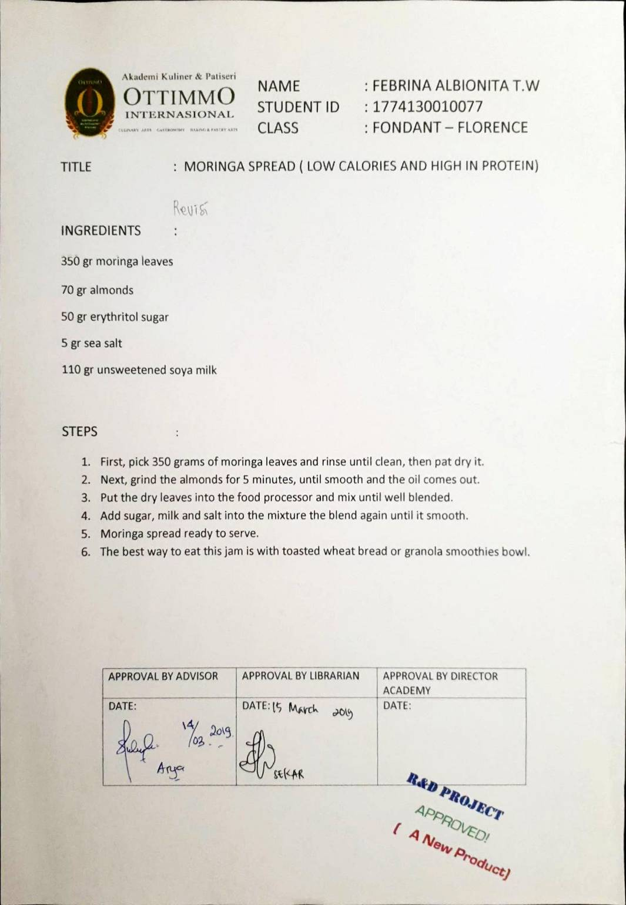

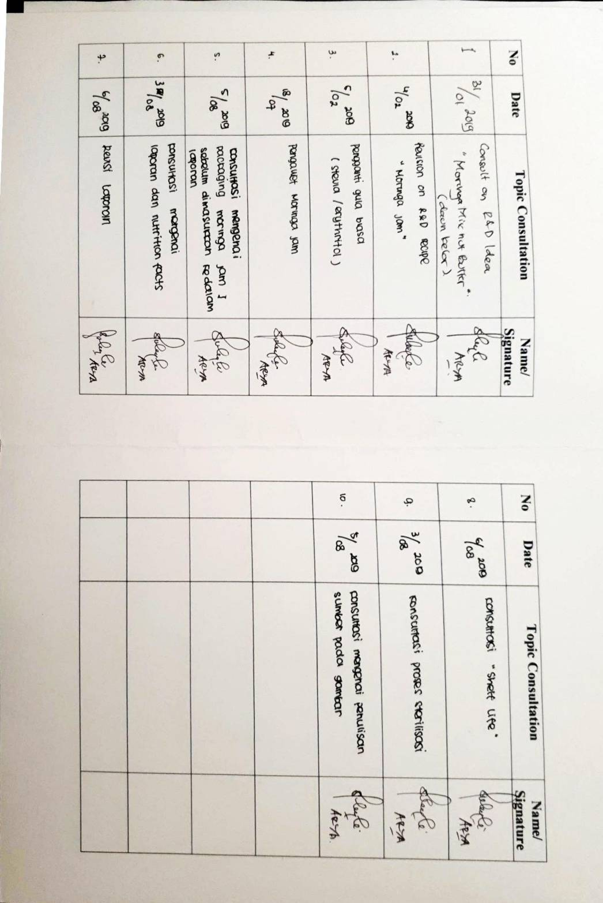

Appendix 1. Packaging Design
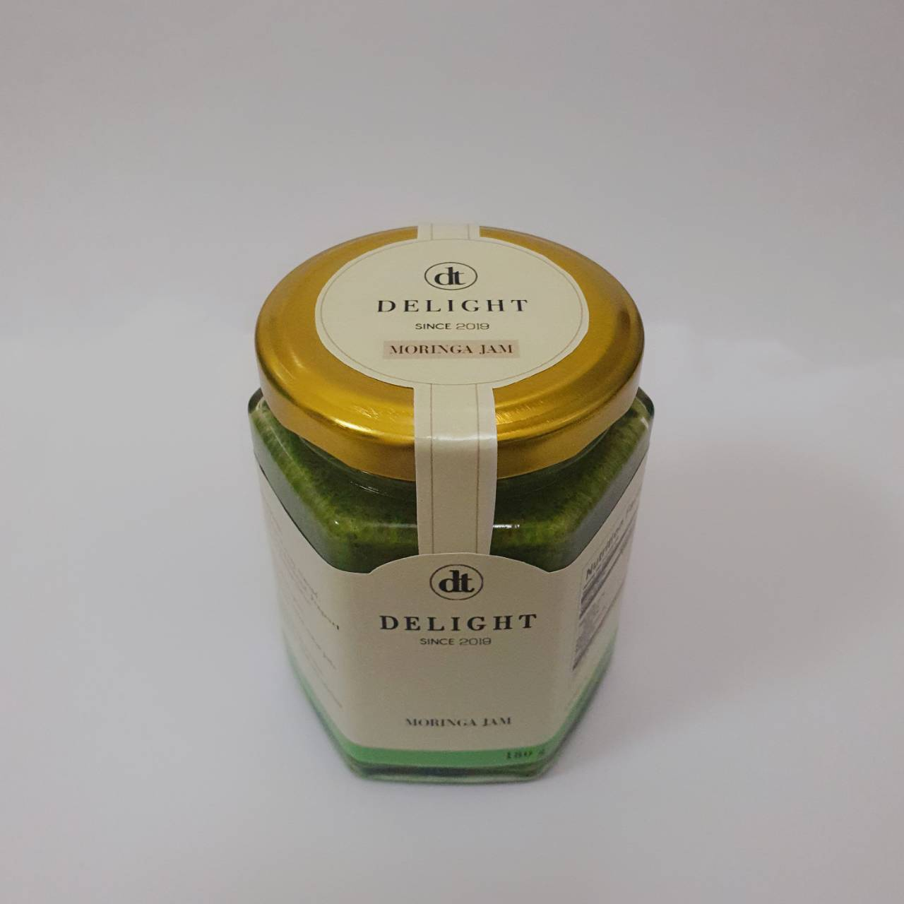

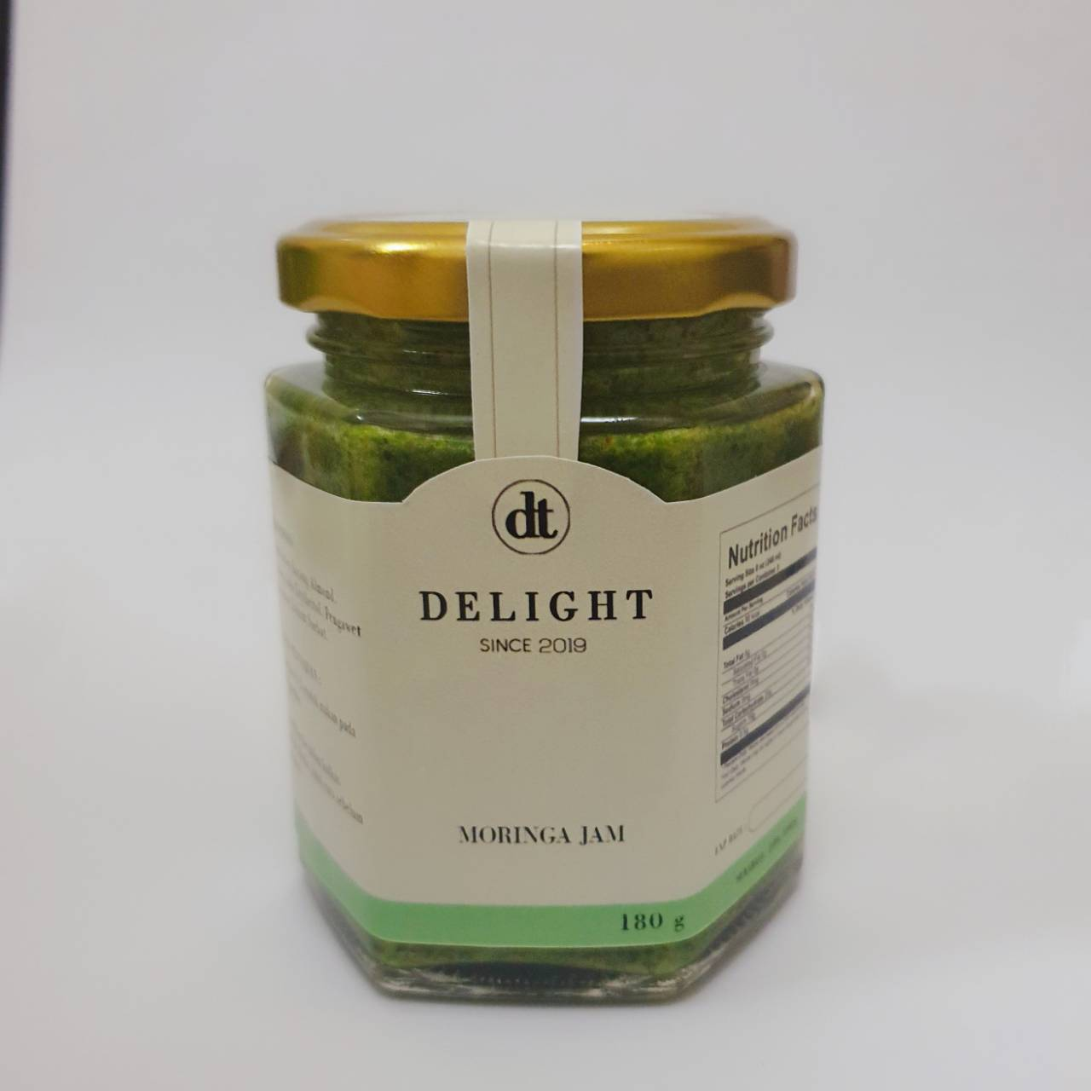
Picture 16 Packaging Design Top Side

Picture 17 Packaging Design Front Side

Appendix 2. Product Logo
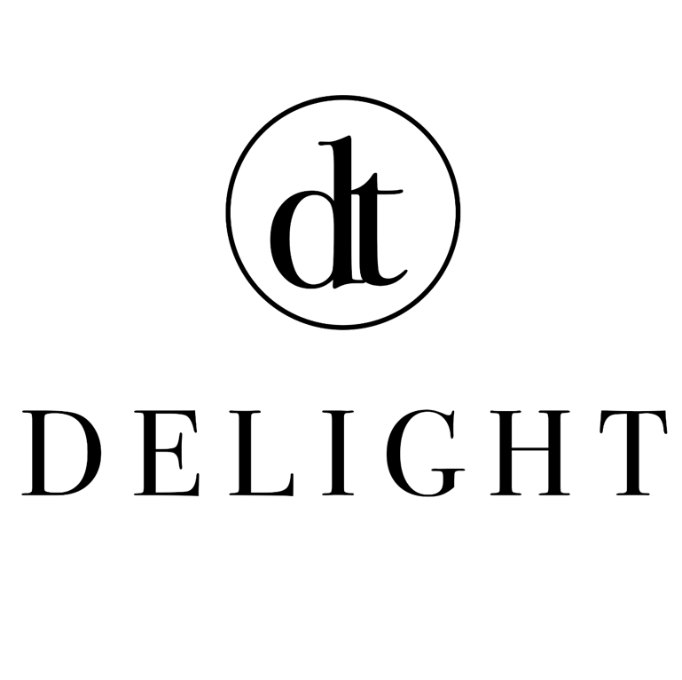

Picture 18 Product Logo
Appendix 3. Design Packaging Without the Jar

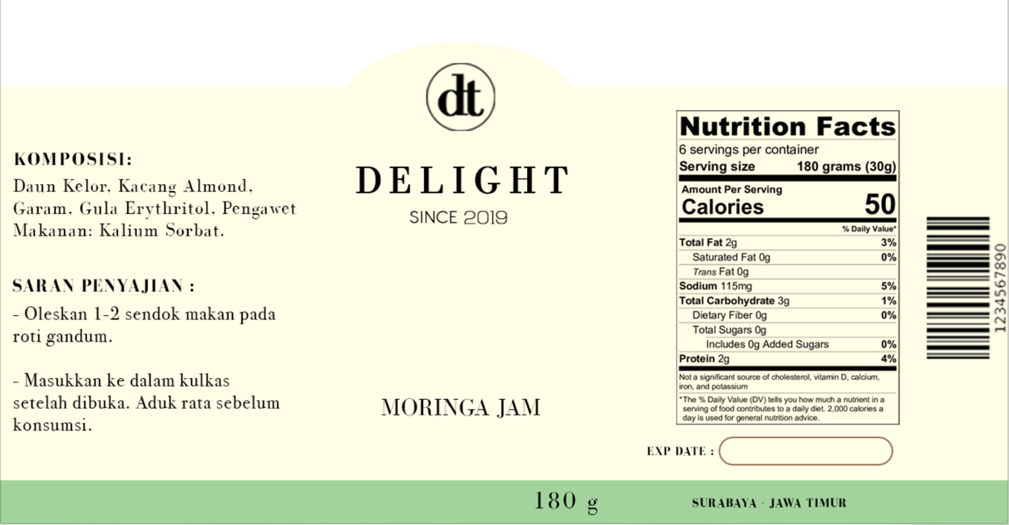
Picture 19 Design Packaging Front Side without the Jar

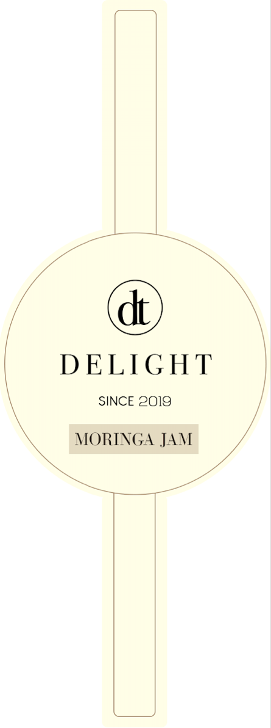
Picture 20 Design packaging without the Jar

Appendix 4. Supplier List
1. Moringa Leaves
The Moringa Leaves that we use for the main ingredients is pick from our plants. We plants the moringa in our working area.

2. Erythritol Sugar
The sugar that we use is bought from Healthy Corner Sby
https://shopee.co.id/Erythritol-Natural-Pemanis-Alami-Diabetes-250-gr-MH-Food-i.2588472.1804464075
3. Roasted Almond
The roasted almond that we use, we buy from cendana.shopp
https://shopee.co.id/Roasted-Almond-Almond-Kupas-Panggang-(500-Gr)-i.163023070.2478446559

4. Soy Milk
The soy milk that we use is from Pasar kepatihan because we have to use the soy milk that without any sugar also can be called pure soy milk, that is located at
Jl. Kramat Gantung No.7, Alun-alun Contong, Kec. Bubutan, Kota SBY, Jawa Timur 60174

- Sea Salt
The sea salt that we use is from Pasar kepatihan , that is located at,
Jl. Kramat Gantung No.7, Alun-alun Contong, Kec. Bubutan, Kota SBY, Jawa Timur 60174

6. Packaging Jar
The packaging jar is bought from Fukupak Printing Store located at,
Jl.Raya Darmo Permai I No. 69, Pradahkalikendal, Dukuh Pakis, Kota SBY,
Jawa Timur 60226.

7. Packaging Sticker
We use the Vinyl Sticker Type for the packaging sticker which we order
from Global Art that located at,
Kompleks ruko San Diego , Pakuwon City Surabaya MR2-20 (103, Kejawaan Putih Tamba, Kec. Mulyorejo, Kota SBY, Jawa Timur 60111

Picture 11 Electric Scale (Anonymous, 2019)
Picture 12 Glass Jar (Anonymous, 2019)
Picture 13 Spoon (Anonymous, 2019)
Picture 14 Pan (Anonymous, 2019)
Picture 15 Stove (Anonymous, 2019)
Picture 16 Packaging Design Top Side
Picture 17 Packaging Design Front Side
Picture 18 Product Logo
Picture 19 Design Packaging Front Side without the Jar
Picture 20 Design Packaging without the Jar

