RESEARCH AND DEVELOPMENT FINAL PROJECT
“ MORINGA SPREAD ( LOW CALORIES AND HIGH IN PROTEIN)”

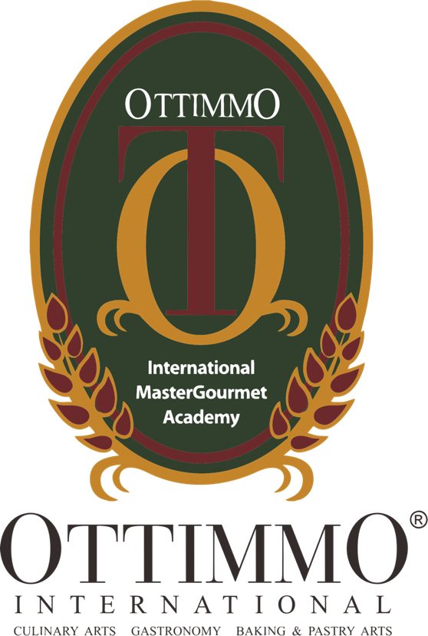

By
FEBRINA ALBIONITA TJANDRA WIJAYA
1774130010076

CULINARY ARTS STUDY PROGRAM
OTTIMMO INTERNATIONAL MASTERGOURMET ACADEMY
SURABAYA
2019
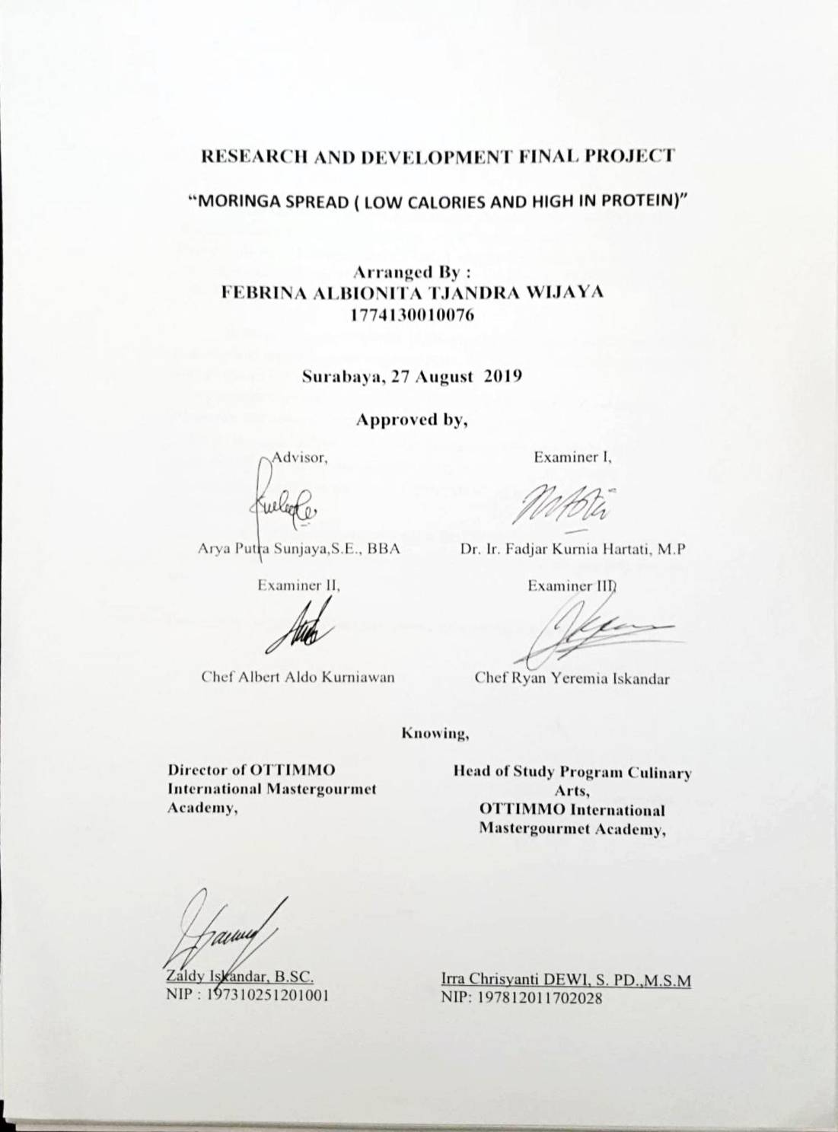
ACKNOWLEDGMENT

Praise and thanks to God Almighty for the successful completion of this report. The author can complete the writing of Research and Development Final Project Entitled” Moringa Spread ( Low Calories and High in Protein)” This report is prepared as one of the requirements to complete the Diploma III of Culinary Arts.

In the process of completion of this report, the Author has received much guidance and assistance from various parties. To that end, the authors express their sincere thanks to:
1. My parents who always support me whatever I do, provided me a good education and always give strength to achieve my goals.
2. Mr Arya Sunjaya Putra as Advisor who has guided, provide guidance and suggestions until the completion of this report.
3. Mr Zaldy Iskandar as Director of OTTIMMO International MasterGourmet Academy Surabaya.
4. Miss Irra Chrisyanti Dewias Head of the Culinary Arts Study Programme.
5. Last, I want to thank you to all of my friends who give already help me until now.

Finally, the Authors hope that this report can be useful for us all.

Surabaya, 28th August,2019

Febrina Albionita

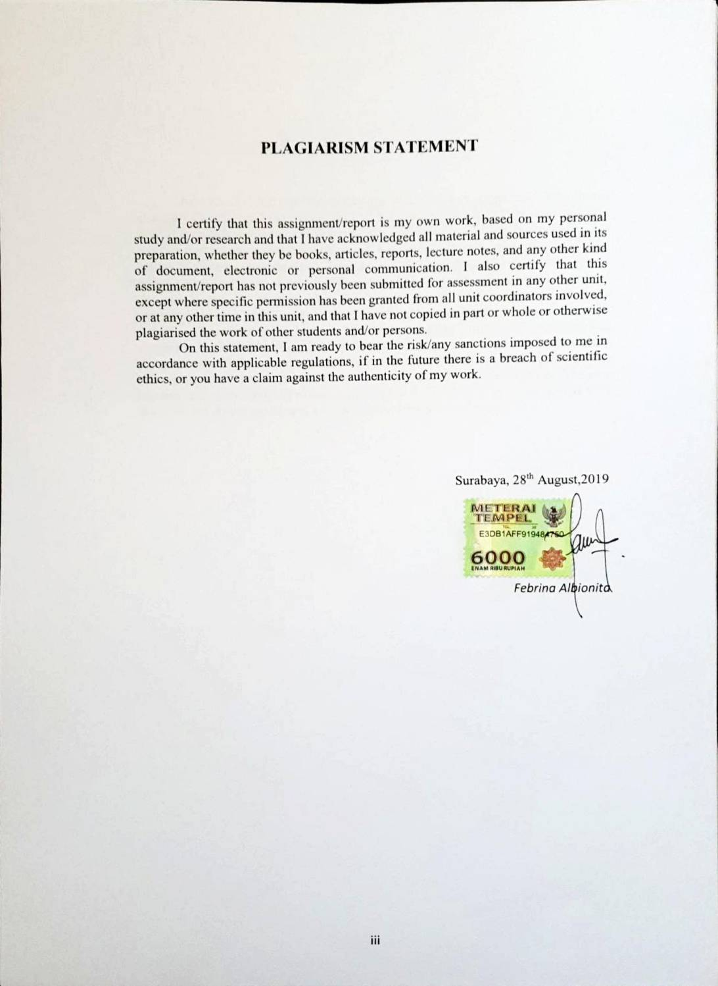

Executive Summary

Nowadays, Moringa Oleifera being called the new superfood. This leaves is a nutrient-rich tree, is known to ancient cultures as the “tree of life” and “miracle tree” due to its impressive nutritional profile and long list of medicinal benefits. All parts of the tree are safe for consumption, but the leaf is most commonly used. The leaves of the tree are harvested, dried up and then crushed. The final product is a powder similar in taste to matcha (Roasted green tea) with a little bit bitter taste at the end. It and can be enjoyed in the form of tea, powder, or capsule. Moringa oleifera is loaded with nutrients which produce an abundance of powerful health benefits. This super-green has an impressive nutritional profile, is more nutrient dense than kale and blows goji berries away with its antioxidant levels. In a gram per gram comparison, moringa oleifera contains seven times as much vitamin C as an orange, four times as much calcium as milk, three times as much potassium as a banana, and three times as much iron as spinach. The leaves also contain all 9 of the essential amino acids, and are considered a complete protein.

Keywords : Moringa, Spread, Almond, Soy Milk, Erythritol (Sugar Alcohol)
TABLE OF CONTENTS

i
ii
iii
iv
v
vi
vii
1
1
2

3
3

12
12
16
17

18
18
18
19

20
20
21
21
22

26
26
26
28
30

APPROVAL
ACKNOWLEDGMENT
PLAGIARISM STATEMENT
EXECUTIVE SUMMARY
TABLE OF CONTENTS
LIST OF TABLE
LIST OF PICTURE
CHAPTER I INTRODUCTION
  - Background
  - Objective

CHAPTER II INGREDIENTS
2.1 Description Of The Material To Be Used

CHAPTER III NEW PRODUCT PROCESSING SEQUENCE
3.1 Utensils Overview
3.2 The Processing Product By Using Flowchart
3.3 Complete Recipe Attached

CHAPTER IV NEW PRODUCT OVERVIEW
4.1 The Facts of Nutrition
4.2 New Product Characteristic
4.3 Product Shelf Life

CHAPTER V BUSINESS PLAN
5.1 Identification of Investment Opportunities
5.2 Marketing Aspect
5.3 Technical Aspect
5.4 Financial Aspect

CHAPTER VI CONCLUSION
6.1 Conclusion
6.2 Suggestion
PREFERENCES
APPENDIX

