INDUSTRIAL TRAINING REPORT
Internship Report at Restaurant Locavore
“Go Local or Go Home”
UBUD, BALI
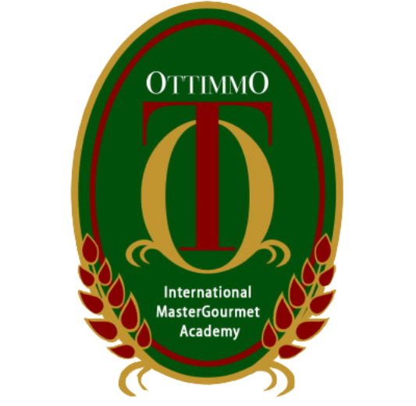

Arranged by:
Thalia Oka Setiawan
NIK: 1774130010083

STUDY PROGRAM OF CULINARY ART
OTTIMMO INTERNATIONAL MASTERGOURMET ACADEMY
SURABAYA
2020

APPROVAL

Title : Internship Report at Restaurant LOCAVORE “Go Local or Go Home”
Company Name : Restaurant Locavore
Company Address : 10 Jalan Dewi Sita, Ubud, Bali, Indonesia
Phone : 62(0) 361977733
This carried out by Students of Culinary Arts OTTIMMO International MasterGourmet Academy Surabaya
Name : Thalia Oka Setiawan
Reg. No : 1774130010083

has been tested and declared successful.

Approved,
Advisor

Chef Gilbert Yanuar Hadiwirawan
19900101701041
Ubud, 1st July 2020
Supervisor

Eelke Plasmeijer Ray Ardiansyah

Knowing,
Director of OTTIMMO International MasterGourmet Academy Surabaya

Zaldy Iskandar, B Sc
NIP: 197310251201001

INTERNSHIP REPORT
at Restaurant LOCAVORE “ Go Local or Go Home”

Arranged by:
THALIA OKA SETIAWAN
Finished the internship period from 7th October 2019 until 20th March at Restaurant Locavore
Approved by,

Supervisor,

Chef Gilbert Yanuar Hadiwirawan
19900101701041
Examiner II,

Nurul Azizah Choiriyah, S.TP, M.Sc
199002152002071
Examiner I,

Latihfahtur Rahmah, S.Pd., M.Pd
199402252002070

Knowing,

Director of OTTIMMO International Mastergourmet Academy,

Zaldy Iskandar, B.SC,
NIP: 197310251201001

Head of Study Program Culinary art, OTTIMMO Internattional Mastergourmet Academy,

Irra Chrisyanti Dewi, S.Pd, M.S.,
NIP: 19781201170202

ACKNOWLEDGEMENT
In preparation of my 6 months of internship at Restaurant Locavore Ubud Bali, I had to take the help and guidance of some respected persons, who deserve my deepest gratitude. As the completion of this assignment gave me much pleasure, I would like to show my gratitude to Chef Zaldy Iskandar, Chef Arya Putra Sunjaya, Miss Yohanna and all the lectures on Ottiommo International MasterGourmet Academy who expertly guided the author through the graduated education.
In addition, I would also like to show gratitude to all of the chefs and staffs at Restaurant Locavore. Chef Eelke Plasmeijer and Chef ray Ardiyansyah, Bli Cool and Chef Nando who have introduced me to the Methodology of work and preparation in Restaurant Locavore, and also I want to thank Aji Jhose, Bli Jablay, Mang Edi, Boss, Dian, Monica, Krishka, Fanda, Tommy, Chandra, Vera, Apri, Verrel, Kani, Aji Droga, Pak Ketut, Pak Teh, Pak Wayan and so on who have made valuable mentoring, encouragement, endless support and understanding spirit during my internship program.
And finally, most importantly last but by no means least, I must express my very profound gratitude to my parents and to my friends for providing me with unfailing support and continuous encouragement throughout my months of study and through the process of working under pressure and writing this project. This accomplishment would not have been possible without them. This dissertation stands as a testament to your unconditional love and encouragement.

PLAGIARISM STATEMENT

I certify that this assignment nor report is fully based on my own work and personal study or research. and that I have acknowledged all material and sources used in its preparation, whether they be books, articles, reports, lecture notes, and any other kind of document, electronic or personal communication. I also certify that this assignment/report has not previously been submitted for assessment in any other unit, except where specific permission has been granted from all unit coordinators involved, or at any other time in this unit, and that I have not copied in part or whole or otherwise plagiarized the work of other students and/or persons.
On this statement, I am ready to bear the risk/any sanctions imposed to me in accordance with applicable regulations, if in the future there is a breach of scientific ethics, or you have a claim against the authenticity of my work.

Denpasar, 1st July 2020

Thalia Oka Setiawan

TABLE OF CONTENTS
APPROVAL ii
ACKNOWLEDGEMENT iv
LIST OF PICTURE viii
LIST OF TABLE x
EXECUTIVE SUMMARY xi
CHAPTER I 1
INTRODUCTION 1
1.1 Background 1
1.2. Objective 1
1.3. Benefit of Internship 2
CHAPTER II 4
GENERAL DESCRIPTION OF RESTAURANT LOCAVORE 4
2.1 History of Restaurant Locavore 4
2.2. Overview 6
2.2.1. Logo 7
2.2.2. About 8
2.3. Features of Restaurant Locavore 9
2.3.1. Nusantara 9
2.3.2. Night Rooster 10
2.3.3. Locavore To Go 11
2.3.4. Local Parts 12
2.3.5. Loca Lab 13
2.4. Management Biography 15
2.4.1. Executive Chef 15
2.4.1 Restaurant Manager 17
2.5. Organizational Structure 18
2.6. Hygiene and Sanitation Standard in Restaurant Locavore 18
2.6.1. Personal 18
2.6.2. Kitchen 19
2.6.3. Ingredient 19
2.7. Kitchen Map 20
CHAPTER III 21
3.1. Place of Assignment 21
3.2. Activities Performed and Job Description 21
3.3 Additional Activities 27
3.4 Problem Faced and How to Solve Them 27
3.5. Product of Internship 29
CHAPTER IV 39
4.1. Conclusion 39
4.2 Suggestion 39
REFERENCE 41
APPENDIX 42

LIST OF PICTURE

Picture 2.1.1 Locavore’s People 4
Picture 2.1.2 Locavore’s Interior 5
Picture 2.2.3 Locavore in Asia’s 50 Best Restaurant 2019 6
Picture 2.2.4 Logo Restaurant Locavore 7
Picture 2.2.5 Location of Restaurant Locavore 8
Picture 2.3.6 Nusantara by Locavore 9
Picture 2.3.7 Inside of Nusantara 10
Picture 2.3.8 Night Rooster by Locavore 11
Picture 2.3.9 Night Rooster Product 11
Picture 2.3.10 Product of Locavore To Go 12
Picture 2.3.11 Product of Local Parts 13
Picture 2.3.12 Inside of LocaLab 14
Picture 2.4.13 Executive Chef, Eelke Plasmeijer 15
Picture 2.4.14 Executive Chef, Ray Ardiansyah 16
Picture 2.4.15 Restaurant Manager, Adi Karmayasa 17
Picture 2.7.16 Kitchen Map 20
Picture 3.5.17 Canang Sari 29
Picture 3.5.18 Monkey Business 29
Picture 3.5.19 Black Rice Blini 30
Picture 3.5.20 Frangipani Tempura 31
Picture 3.5.21 Hot and Cold Tomato 31
Picture 3.5.22 Old and New Rambutan 32
Picture 3.5.23 Fermented Cassava Bread 32
Picture 3.5.24 Yam Fries 33
Picture 3.5.25 Prawn & Cucumber 33
Picture 3.5.26 Lamb Curry Tartare 34
Picture 3.5.27 Edi Broccoli 34
Picture 3.5.28 Sea Urchin 35
Picture 3.5.29 Lobster & Durian 35
Picture 3.5.30 Chinese Cabbage 36
Picture 3.5.31 Sweet and Sour Mango Sorbet 36
Picture 3.5.32 Kue Boni 37
Picture 3.5.33 Bali Chocolate 37
Picture 3.5.34 Congklak 38

LIST OF TABLE

Table 2.5.1. Organizational Structure ................................................................ 18
Table 3.2.2. Activities Performed and Job Description ..................................... 26

EXECUTIVE SUMMARY
The writing of this industrial training report is one of the requirements to fulfill graduation regulation. This report is written based on a training program at Restaurant Locavore from $7^{th}$ October 2019 – ${20}^{th}$ March 2020. The objectives of the study are to study & to analyze the working system and to identify the problems in a restaurant.

Restaurant Locavore serves Modern Cuisine with Balinese Local Ingredients with the concept of Zero Waste. This report is divided into four chapters. The first chapter of this study deals with introductions that present the objectives and the benefit of the internship itself as for us student, Ottimmo International MasterGourmet Academy Surabaya, and also for Restaurant Locavore. The second chapter of the study deals with some general description of Restaurant Locavore, History, Overview, and other theoretical concept about profile of Restaurant Locavore. The third chapter is about the conceptual framework of credit management activities and the problem solving of Restaurant Locavore. The fourth chapter is about conclusions and recommendations which are drawn by analysis of whole study.

The main findings of the study are as follows: to learn on how the real workplace and directly being supervised by seniors that certainly have more experience and expertise in their fields. As an Internships Student in Restaurant Locavore, an intern is not just a runner nor a chopping guy, we are also been given the opportunity to have a responsibility in our station.

Keyword: Restaurant Locavore, Local Ingredients, Modern Cuisine, Zero Waste.

CHAPTER I

INTRODUCTION
  - Background
Internship program has become the bridge for those who want to enter to workforce from the college life, through internship the writer got to know the real working environment that was totally different from her course study. During my internship, the writer got a chance to work in one of the best restaurant in Asia and the best restaurant in Indonesia based on The World’s 50 Best Restaurant Asia Region sponsored by S. Pellegrino & Acqua Panna.
Restaurant Locavore, located in the center of Ubud managed by Eelke Plasmeijer and Ray Ardiansyah as the executive chefs. In 5 years, they succeed to reach lots of appreciation through the dishes. Once Eelke said, he never expects to build a restaurant to winning an award – but he still thank God for that. He just feels really happy and satisfied when he can serve the best food he can make and all guests feel the same way as him with the food they serve.
Therefore, this is a big opportunity for the writer to have intern in their restaurant. They give the writer a chance to work in not only one section but in three sections which are Hot Section, Cold Section or Starter and Pastry. All section has thought the writer to be responsible, discipline, punctual, dexterous and sacrificial person. Hopefully, this valuable experience working at Restaurant Locavore can be useful and bring tons of learning to face the real life kitchen after the writer graduate from Ottimmo International Master Gourmet Academy Surabaya.
- Objective
- Meet one of the requirements of Diploma 3 at Ottimmo International Master Gourmet Academy
- Learn by doing how to work agile in real kitchen.
- Develop abilities by practice in real kitchen.
- Improve the ability to speak with guest.
- Get used to work as a team.
- Increase sense of responsibility for work.
- Find out the important of cleanliness in serving food.
- Benefit of Internship
- Benefit of Internship for Student
- Become the bridge for those who want to enter to workforce from the college life, through internship the writer’s know the real working environment that was totally different from course study.
- Able to work under pressure.
- Increase creativity in making food with existing ingredients.
- Able to find solution and shortcut in precarious situation.
- Improve the knowledge about cooking techniques and local ingredients.
- Understand the employee high standard that restaurant needs.
- Learn how to solve problems.
- Able to work in limited space and time.
- As medium for self-development of initiative, responsible, sacrificial and agile.
- Improve communication skill between employees and guests.
- Benefit of Internship for Ottimmo International MasterGourmet Academy Surabaya
- Build a good business relation between Ottimmo International Master Gourmet Academy Surabaya and Restaurant Locavore.
- As a guideline for juniors to choose the place of internship that suits to their ability.
- Become a benchmark for knowing how well students are and adjust the curriculum for the future.
- To widen Ottimmo International Master Gourmet Academy Surabaya publication range.
- Benefit of Internship for Restaurant Locavore
- Build a good business relation between Restaurant Locavore and Ottimmo International Master Gourmet Academy Surabaya.
- As a medium to find a potential employee.
- Increase productivity in kitchen.

CHAPTER II

GENERAL DESCRIPTION OF RESTAURANT LOCAVORE

2.1 History of Restaurant Locavore
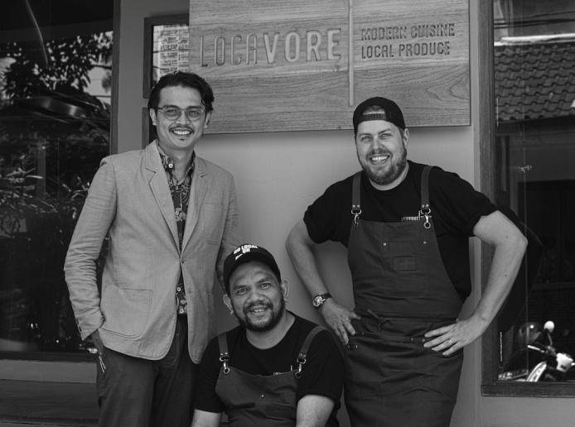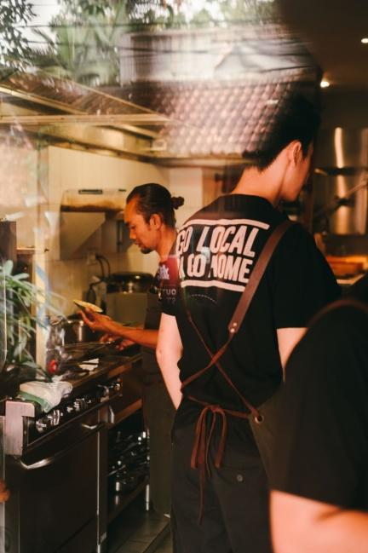
Picture 2.1.1. Locavore’s People.
(Personal Documentation, 2019).
Locavore is a small and cozy restaurant operated by a team of highly dedicated food enthusiasts whose primary goal is to ensure their guests savor their experience at Locavore while dining on artistically prepared fresh and highly enjoyable dishes. Part of that process is to source 95% of their products locally and not to keep large stocks but rather to source as much.
Perhaps the only import at Locavore is Eelke Plasmeijer, a Dutch- born chef who moved to Jakarta in 2008. There he met fellow head chef Ray Adriansyah, who was born in Jakarta to Sumatran parents, and the pair soon moved to Bali where they ran the kitchen at Alila Ubud. Combining their passion for cooking with sustainably sourced local ingredients, Eelke and Ray decided to take the concept to the next level, teaming up with restaurant manager Adi Karmayasa to create Locavore in November 2013.
As the catalysts between local producers and discriminating diners, Ray and Eelke’s ingredient-driven menu celebrates the farmers, fishers and food artisans of Indonesia. Through these ongoing relationships, they ensure their guests the freshest of seasonal produce and ethically fed meat animals. And by working closely with local farmers, Locavore supports sustainability within its community.
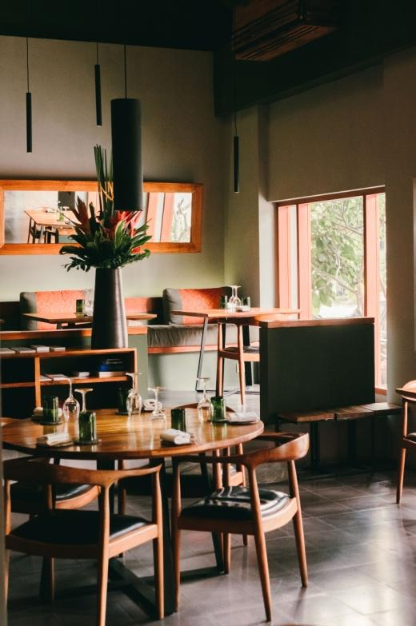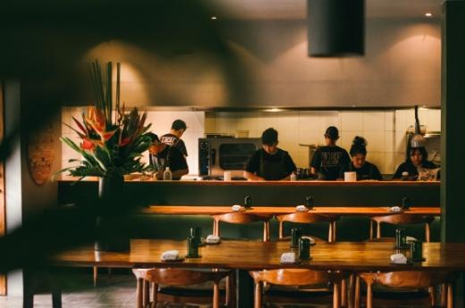
Picture 2.1.2. Locavore’s Interior
(Personal Documentation, 2019).
Over 95% of the kitchen’s ingredients are Indonesian. Locally produced vegetables and herbs further reduce the huge carbon footprint of imported foods. The kitchen uses Kintamani coffee, hand-crafted sea salt from north Bali, spices from the mountains and fresh seafood from Eastern Indonesia. Eelke and Ray painstakingly source the animals they use in their kitchens, ensuring that they were free ranged, raised on wholesome natural foods and dispatched with respect. The chefs honour the animals they use with creative dishes in which very little is wasted.
The marriage of fresh, local ingredients with the inspired dishes of these prize-winning chefs has proved enormously popular with international diners who love both the concept and the food. Book at least two weeks in advance for a dinner table.
As Locavore continues grow, so does its outstanding team. Ray and Eelke’s human resource philosophy is to hire not on the basis of experience but for attitude, social skills and willingness to learn. They carefully train the employees, give them responsibility and let them fly. Locavore, Nusantara, Night Rooster, Locavore to Go and Local Parts are now served by over 60 dedicated and enthusiastic staff from all over the country.

2.2. Overview
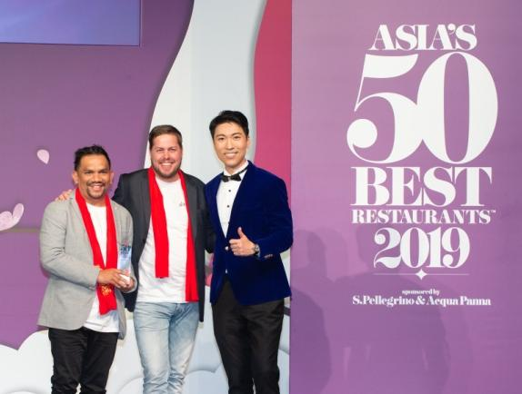
Picture 2.2.3. Locavore in Asia’s 50 Best Restaurant 2019
(Anonymous, 2019).
Locavore takes its name from eco-conscious food movement ‘Locavorism’, which aims to reduce food miles by relying on produce grown within 100-250km radius of the customer’s kitchen. Locavore has a unique selling point: it will feature European dishes prepared only with local ingredients. Locavore Restaurant are and aim to continue being a fine dining establishment that focuses equal parts on the cuisine and on the experience. (Anonymous, 2018).
To ensure that experience consist of the highest quality, Locavore focuses on a series of set tasting menus; used to be 5-courses or 7-courses menu to 6-courses or 9-courses in either Locavore (meat) or Herbivore (vegetables) menu. For those with dietary preferences can able to modify the set tasting menu also. The chef loves to be challenged to meet new heights, some may call those preferences a dietary restriction but Locavore’s chef simply view the preferences as part of their obligation to ensure every guest enjoy the experience at Restaurant Locavore.
On the other hand, Locavore also awarded as the best restaurant in Indonesia based on Asia’s 50 Best Restaurant forth times in a row, especially in Individual Country Winner category. In 2016 and 2017 restaurants that are thick with nuances of typical European interior design are also able to reach the 49th and 22nd rankings. This drastic increase in rank also makes Locavore awarded The Highest Climber Award because it manages to jump to 27 ratings at once. In 2018 and 2019 ranked at 21st and 42nd.
- Logo
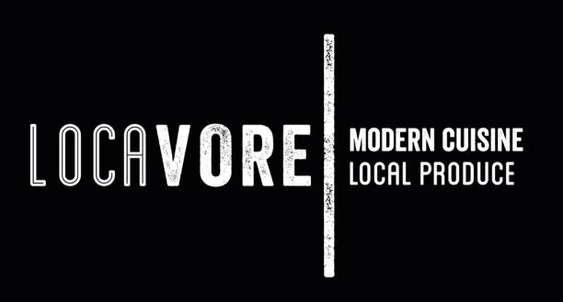

Picture 2.2.4. Logo of Restaurant Locavore

(Anonymous, 2019)

- About
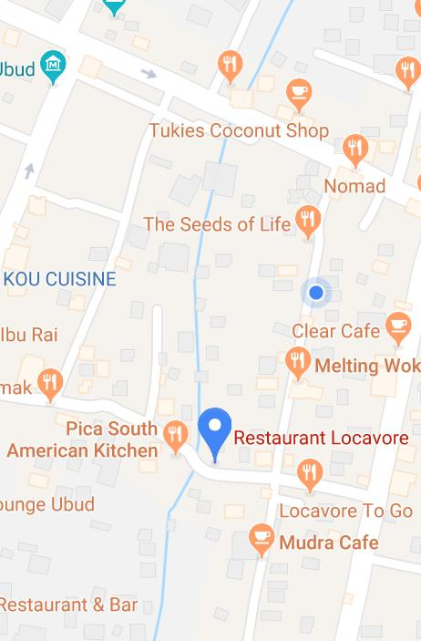
Picture 2.2.5. Location of Restauran Locavore
(Anonymous, 2019)
Hours of Operation
Lunch : Tuesday to Saturday 12:00 - 14:30
Dinner : Monday to Saturday 18:30 - 22:00
Address : 10 Jalan Dewi Sita, Ubud, Bali, Indonesia
Phone : +62(0) 3619 777 33
Parking may be a challenge. We recommend you to be dropped off by a driver.
Dress code : Relax and casual, but alcohol branded clothing, singlet or other beachwear is not allowed.
Children or Kids are welcome as long as they are well behaved.

2.3. Features of Restaurant Locavore

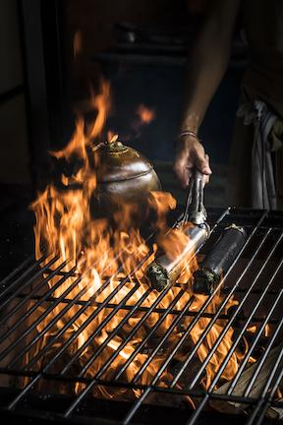
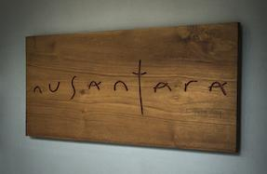
2.3.1. Nusantara

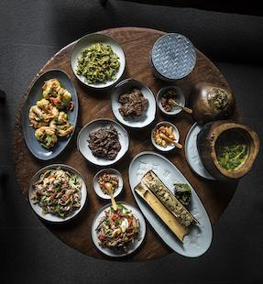

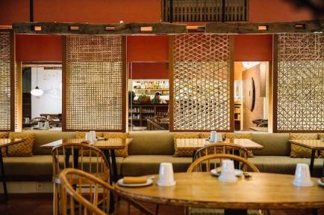

Picture 2.3.6. Nusantara by Locavore
(Personal Documentation, 2019)
Locavore takes its philosophy of seeking out Indonesian ingredients across the street to its newest restaurant. Nusantara is Indonesian for ‘archipelago’ -- the thousands of diverse islands that make up the country of Indonesia. Here, classic Indonesian dishes from all over the nation are celebrated by chefs who combine the freshest of local, seasonal components and ethical meats in nuanced, artisanal recipes.
Balinese Chef Putu and his sous chefs from West Java, Medan and North Sumatra are constantly coming up with new dishes to keep the menu fresh. This authentic Indonesian restaurant offers a unique version of the country’s rich culinary heritage. The menu focuses on traditional flavors from across the Indonesian archipelago, bringing authentic, less-known regional dishes to diners from around the world in a casual environment. Busy from the day it opened its doors in mid-2017, Nusantara is set to become one of the most intriguing Indonesian fine dining restaurants in the country.
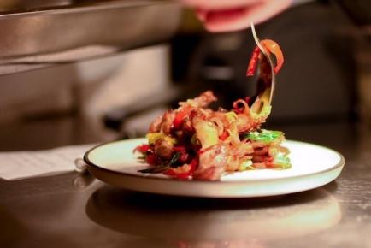
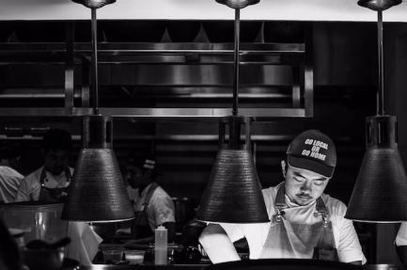

Picture 2.3.7. Inside of Nusantara
(Personal Documentation, 2019)
Hours of operation:
Lunch : Tuesday to Sunday 12:00 - 14:30
Dinner : Monday to Sunday 18:00 - 22:00
Address : Jalan Dewi Sita, Ubud, Bali, Indonesia
Phone : +62(0) 3619 729 73

2.3.2. Night Rooster
Locavore’s bar Night Rooster is located between the restaurant and Locavore To Go/Local Parts and offers charming views of Jalan Dewi Sita from its second floor location. The airy yet intimate ambiance is enhanced with recycled wood, including a magnificent ironwood floor in the friendly 40-seat bar.
Here alchemist Raka creates exciting cocktails from premium spirits imaginatively combined with local fruits, herbs, vegetables and spices. Raka makes his own bitters and experiments with exotic infusions. His unique cocktails are works of art, both visually and in their subtle, delightful flavors.
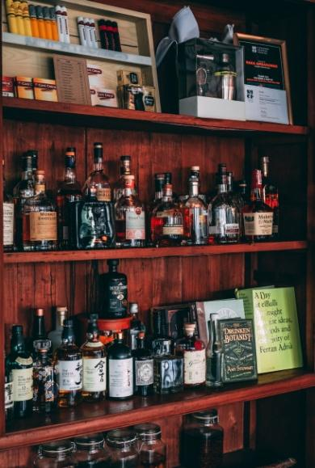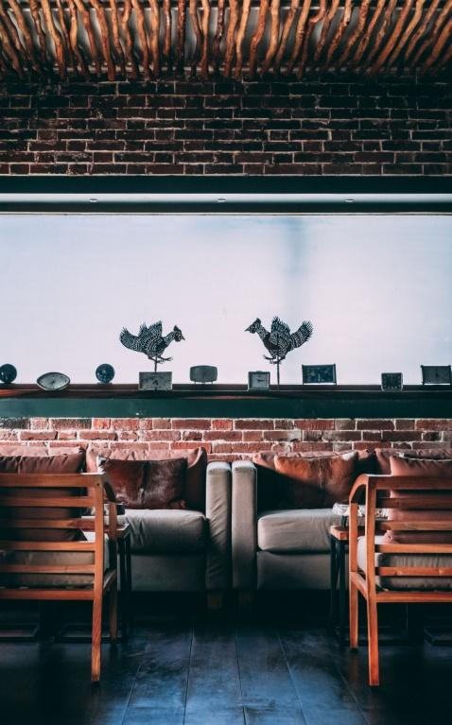
Picture 2.3.8. Night Rooster by Locavore
(Personal Documentation, 2019)
Hours of operation : Monday to Saturday 16:00 until late
Address : 10B Jalan Dewi Sita, Ubud, Bali, Indonesia
Phone : +62(0) 3619 777 33
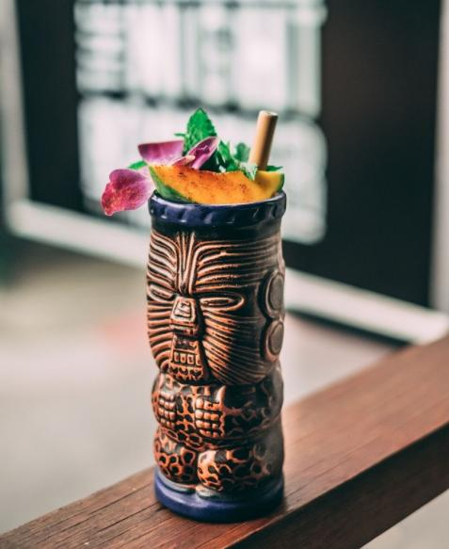
Picture 2.3.9. Night Rooster Product
(Personal Documentation, 2019)

2.3.3. Locavore To Go
Less than a year after opening Locavore’s recycled wood door, Eelke and Ray realized that they needed a larger kitchen and an outlet for their wonderful charcuterie. Locavore to Go has become the little sister of the main restaurant, running as a freestanding outlet serving up to 100 people a day.
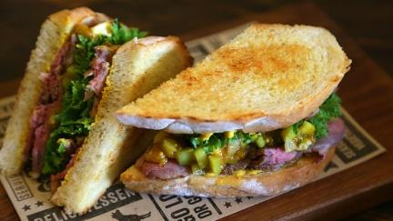
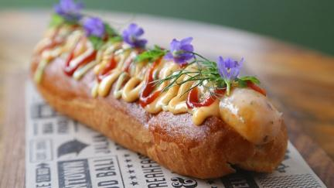
Located 100 meters from Locavore, the cozy restaurant quickly became a popular destination for fresh homemade breakfasts, lunches and snacks throughout the day. The menu features fine deli products and unusual sandwiches.

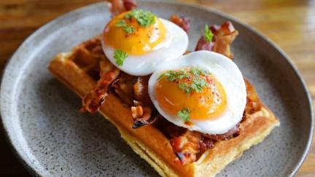
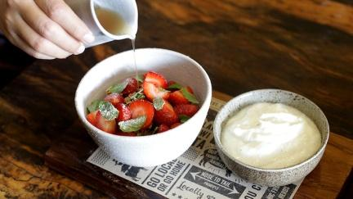

Picture 2.3.10. Product of Locavore To Go
(Personal Documentation, 2019)
Hours of Operation
Monday to Saturday : 8:30 - 19:00
Address :10 3/4 Jalan Dewi Sita, Ubud, Bali
Phone :+62(0) 3619 080 757

2.3.4. Local Parts
Ray and Eelke love working with fine meat, and ensure that all the meat in their new butcher shop is cruelty-free. They have been experimenting for years to perfect their own range of charcuterie. In the bright kitchen behind the shop, chefs produce fresh and air-cured sausages, pates, professional cuts of meat and other delicacies for use in the restaurants and for public sale.
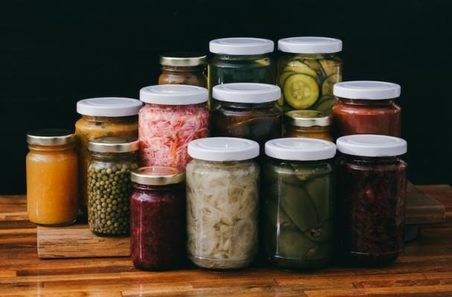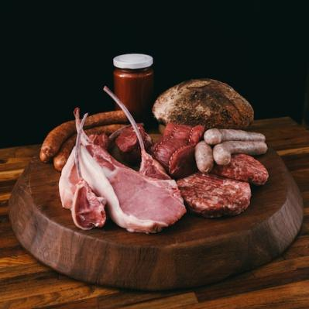
Picture 2.3.11. Product of Local Parts
(Personal Documentation, 2019)
In keeping with Locavore’s nose-to-tail philosophy, customers can expect to see unusual items such as blood sausage and lamb carpaccio. The butcher shop will sell chicken, duck, air- cured Bali beef, Java lamb, rabbit and goat from Bali and pork from traditional black Bali pigs and also hybrid pigs whose meat is more appropriate for bacon. To enhance the charcuterie, the kitchen also makes and sells excellent pickles, preserves and jams.
Hours of operation
Monday to Saturday : 8:30 - 19:00
Address : 10 3/4 Jalan Dewi Sita, Ubud, Bali, Indonesia
Phone : +62(0) 3619 080 757

2.3.5. Loca Lab
Above Nusantara is Localab, a food laboratory and testing kitchen which will be the center of Lacavore’s research and development moving forward. Local ingredients of all kinds meet state-of-the-art techniques and the creative minds of Felix and Fido in an adventure of exploration. They are creating a flavor database of recipes and ingredients.
Localab will also host artisan workshops and serve as a training hub to raise awareness of young Indonesian cooks about the wealth of local food elements available to them.
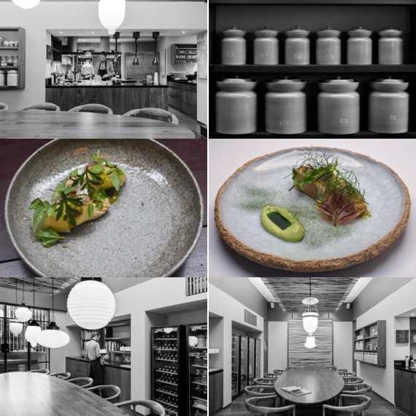

Picture 2.3.12. Inside of LocaLab
(Personal Documentation, 2019)

2.4. Management Biography

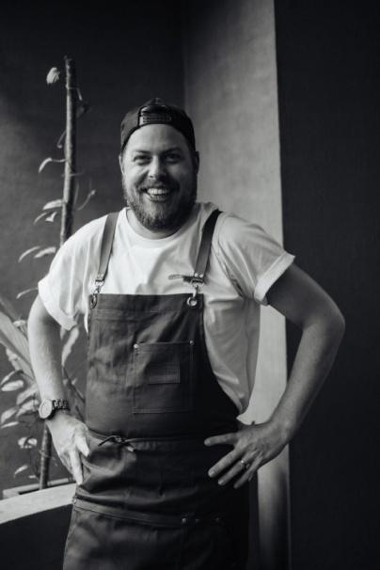
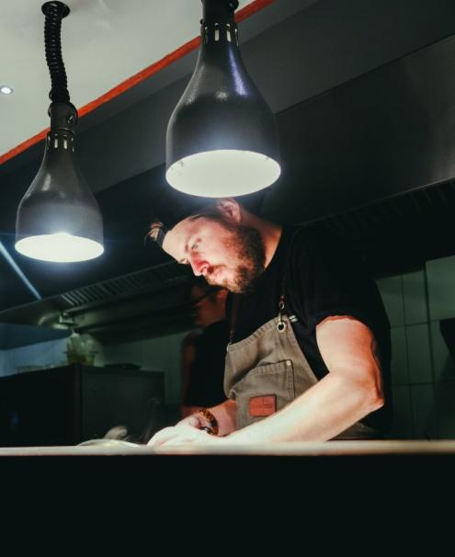
2.4.1. Executive Chef

Picture 2.4.13. Executive Chef, Eelke Plasmeijer
(Personal Documentation, 2019)
EELKE PLASMEIJER started his kitchen career at the age of 14 in a restaurant in his Dutch village. Working his way up through the ranks, he trained at hotel school and a Michelin Two Star restaurant in Amsterdam. Visiting a mentor in Jakarta in 2008, he was persuaded to take over as Head Chef at a city restaurant there. Ray applied as Sous Chef, the two hit it off and soon moved to Bali where they ended up running the kitchen at the Alila Ubud together.
Here they fine-tuned their philosophy of creating exciting tasting menus using primarily local ingredients. They quickly became recognized for their (at that time) unique approach to using only seasonal, local foods. Then they started thinking about leaving the hotel industry to open their own restaurant and the rest is history.

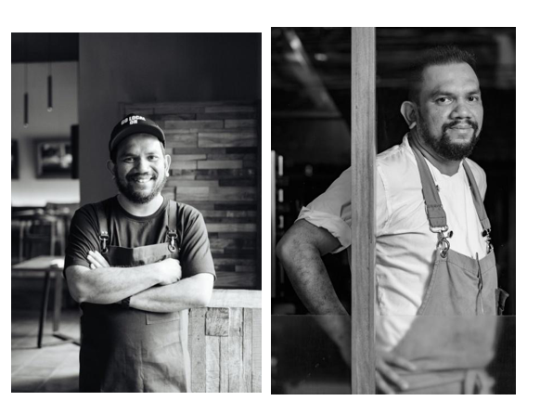

Picture 2.4.14. Executive Chef, Ray Ardiansyah
(Personal Documentation, 2019)
The other executive chef at Locavore is RAY ADRIANSYAH that was born in Jakarta to Sumatran parents. His mother was an excellent cook and Ray grew up with a deep interest in traditional and international cuisines. While studying in New Zealand, he decided to quit the business school he was attending and switch to cooking. After graduating from culinary school in Christchurch he returned to Jakarta and obtained the position of Sous Chef under Eelke. They’ve been working together ever since.
"It was a gradual decision to use local ingredients. We started using a few at the beginning but our commitment continued to grow. I’m very proud to use ingredients that are not imported; I wish more Indonesian chefs would do so. There are so many benefits all round."

2.4.1 Restaurant Manager

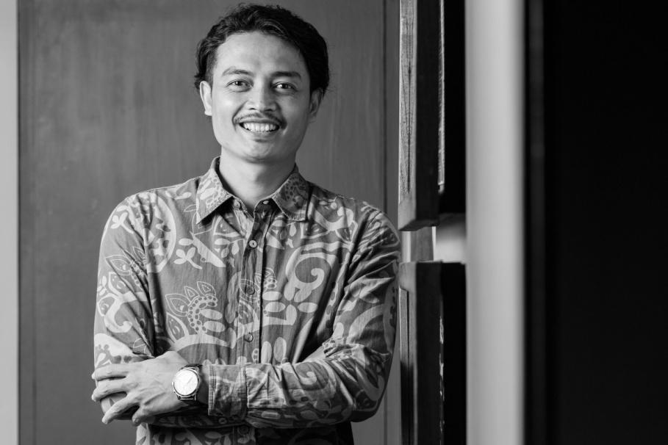
Picture 2.4.15. Restaurant Manager, Adi Karmayasa
(Personal Documentation, 2019)
ADI KARMAYASA, Restaurant Manager, was born in Bedulu village near Ubud. After graduating from tourist school in Denpasar he joined Alila Ubud for job training and was offered a position in 2004. Since then he worked his way up to manage the hotel’s Plantation Restaurant. He worked for 3 1⁄2 years with Eelke and Ray and was invited to join the team when Locavore was conceived.
"Eelke and Ray are my mentors. They introduced me to fine dining and the concept of using local produce. As a Balinese I’m proud to be using local food because it supports our farmers and raises the standards of what they produce. (Anonymous, 2019)

2.5. Organizational Structure

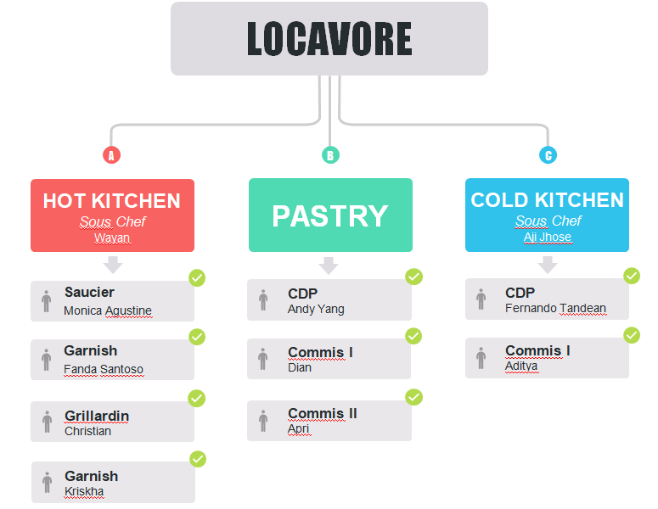
EXECUTIVE CHEF
Eelke Plasmejjer & Ray Ardiansyah

Trainee
Trainee

Trainee

Tabel 2.5.1. Oganizational Structure

2.6. Hygiene and Sanitation Standard in Restaurant Locavore

2.6.1. Personal
- Showering and bathing regularly.
- Keeping hair clean hair, tied back or use cap.
- Keeping clean clothing and footwear that is used only at work.
- Wear proper kitchen wear, like apron.
- Hand washing regularly.
- Using clean utensils for tasting food.
- Using hand gloves or tweezer when handling ready to eat food.

2.6.2. Kitchen
  - Make sure kitchen area in clean condition before and after work.
- Do daily cleaning twice a day after service. Clean station, equipment, utensils and floor with liquid and soap.
- Do deep cleaning once a week like clean the fridge, freezer and oven or sharpen knives (okay, not cleaning, but needs to be done).
- Do general cleaning once a month like wash behind the hotline (oven, stove, fryers) to cut down on grease build up, which is a major fire hazard or wash walls and ceilings.
- Laundry cloth for wiping station or food twice a day. There are different types of cloth based on their function.
- Separate serving area and other areas from the kitchen. Each section has their own space for work (see on kitchen map page 18).
- Use color cutting board. Each color use only for a specific product and function, such as fresh produce, raw meat, poultry or seafood. Clean before and after use, and once they become worn or develop hard-to-clean grooves, they would be replaced.
- Separate trash bin for organic and non-organic trash.

2.6.3. Ingredient
  - Wash all ingredients before process.
  - First In First Out ingredients.
  - Labeling the food product because food products should be properly rotated, which can be done efficiently by correctly labeling and day-dotting all covered food products.
  - Store all ingredients in closed container.
  - Separated area to store ingredients, like meat, seafood, vegetables, fruit and etc.

2.7. Kitchen Map
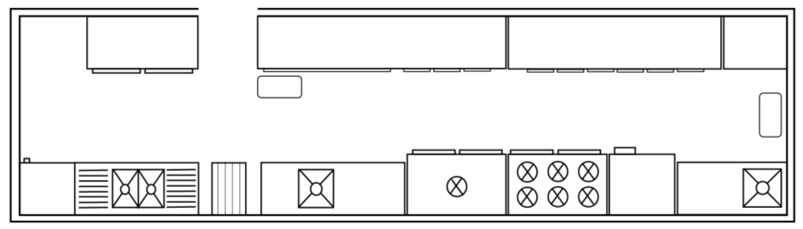

O

O

P

K
A
B
C
D
E
F
G
H
I
J
K
L
M
N
O
Picture 2.7.16. Kitchen Map
(Personal Documentation, 2020)
I : Rational Oven
J : Petit Four Station
K: Trash Bin
L : Pastry Station
M: Cold Section
N : Hot Section
O : Chiller
P : Warmer

A : Freezer
B : Dishwasher Machine
C : Ladder
D : Meat Station
E : Sink
F : Saucier Station
G : Plancha Stove
H : Stove & Oven

CHAPTER III
INDUSTRIAL TRAINING ACTIVITIES

Place of Assignment
On the first day of the internship, I was in charged of checking the supplies and opening the stores from ordering the raw materials and preparation. Followed in the weeks ahead, I was given a job to delegate my co-workers and updating the monthly bookkeeping.

Activities Performed and Job Description

During the internship period, the writer was placed in Cold Section and Pastry. The writer was placed in Cold Section for 4 months from 7th October 2019 to 1st February, in Pastry for 2 months in approximate from 3rd February to 20th March. The working hours, starts from 10 AM to 2AM depending on the preparation of each station.
No. | Date | Job Desk | Activities
1. | 7th October 2019 –  1st February 2020 | Cold Section | - Introduction  - Set up kitchen utensils and equipment  - Make preparation list  - Make order list  - Briefing  - Service  - Interaction with the Guest  - Picking leaves  - Making Sambal Matah  - Making Blini  - Making Smoke Egg Base  - Making Smoke Egg Fmultion  - Making Frangipani Batter  - Making Marigold Emultion  - Making Kecombrang Base  - Making Kecombrang Emultion  - Making Dukkah Crumble  - Dehydrating Leaves  - Making powder from leftovers dried leaves  - Making powder from leftovers dried flowers  - Making Smoked Coconur Sour Crème  - Making Squid Noodles  - Making Kosho  - Making Deche de Tigre  - Making Broccoli Puree  - Blending Cashew Crème  - Making Vichysoisse  - Making fried aromatics for Crunch Mix  - Making Caramelized Peanuts  - Pickling Mariogold Flowers  - Dehydrating corn pulps  - Nixtamelizing corn pulps  - Making Corn Veloute  - Slicing Mango Rose  - Slicing jicama  - Roll mango into flowers  - Making Gingertorch Sauce  - Pickling gingertorch flesh  - Making Soy Lime Vinaigrette  - Making Dukkah Crumble  - Making Edamame Tofu  - Making Edamame Dashi  - Making Lime Vinaigrette  - Making Coconut Sugar Cured  - Slicing cucumber  - Making Thai Pickle Liquid  - Making Burnt Chilli  - Makin Burnt Chilli Oil  - Making Green Gazpacho Vinaigrette  - Grilling Lamb  - Dehydrating aromatics for Curry Powder  - Making Sriracha  - Semi dehydrating tomatoes  - Curing egg yolk  - Making Pickle Water for Watermelon Dish  - Making Mayonnaise  - Making Wasabi Mayonnaise  - Frying grains for Lamb Tartare dish  - Making Smoked egg yolk  - Cleaning stations before and after work  - Deep cleaning once a week  - General cleaning once a month

No. | Date | Job Desk | Activities
1. | 3rd February –  20th March | Pastry | - Introduction  - Set up kitchen utensils and equiptment  - Making preparation list  - Making order list  - Briefing  - Service  - Interaction with the Guest  - Making Vanilla Ice Cream  - Making Strawberry Ice Cream  - Making Chocolate Ice Cream  - Making Tomato Sorbet  - Making Chocholate Ganache  - Making Grape Gel  - Mixing tape mixture for Tape Goreng  - Making Jackfruit Gel  - Making Ganduja Base  - Making Candied Nutmeg  - Blending Toraja Flour  - Making Toraja Cookies  - Making Coffee Cream  - Making Onde – Onde  - Making Miso Base  - Making Miso Cream  - Making Krokkant  - Making Lime Gel  - Making Lemongrass Cream  - Dehydrating pineapple cuts  - Coating pineapple in chocolate  - Making Pineapple Jam  - Making Pie Crumbs  - Making Pastry Cream  - Making Cacao Oil Pie Crust  - Making Bloodberry Reduction  - Making Coconut Egg White Cream  - Making Bloodberry Syrup  - Making Bloodberry Sorbet  - Making Bloodberry Curd  - Making Coconut Gelato  - Making Cacao Soil  - Making Cacao Nougatine  - Making Warm Chocolate Foam  - Making Cacao Syrup  - Making Steamed Cacao Butter Cake  - Making Coconut Yogurt  - Making Cordial  - Making Cacao Butter Gelato  - Making Marination Liquid for White Fruits  - Marinating rambutan  - Marinate lychee  - Making Lassy  - Making Amasake Base  - Making Amasake Gel  - Making Mango Sorbet  - Making Green Mango Sorbet  - Cleaning stations before and after work  - Deep cleaning once a week  - General cleaning once a month

Table 3.2.2. Activities Performed and Job Description
Locavore is a restaurant focusing on local produce while serving modern cuisine. A lot of fermentation included on making each dish. On the first day of the internship, the writer was placed in cold section. From the first, the writer has no knowledge on fermentation at all, but the staffs on locavore are very enthusiast to teach new trainee about fermentation. The writer was in charge in picking 8-10 type of leaves for the garnish, along with 8-10 type of flowers. All leaves and flowers must be washed clean and shocked in ice bath before picking. All leaves and flowers cannot have bruise either way, only the most perfect leaves and flowers is qualified to be served. After two weeks, the writer got a chance to learn how to make the different kinds of emulsion of each dish and how to do fermentation and making pickles. Pickling and fermenting are two different methods. Pickling is a method of food preservation that works by immersing foods in an acidic solution, such as vinegar, that changes both texture and taste of the food. It also involves the use of heat, which is to destroy and inhibit the growth of any microorganisms. Fermentation doesn't require an added acidic liquid or heat, it can be accomplished with as little as a container and salt. The writer also got the chance to explain each dish to the guest.

Second and last section, the writer was put in Pastry Section. Unlike other restaurants and resorts that have big, cold, special room for pastry team, in Locavore the pastry kitchen is placed together with the Locavore To Go kitchen. Small, warm, and yet the ice cream still managed to survived the heat. Pastry thought me a lot about consistency and timing. Especially when it comes to service hours. We pastry team have to go back and forth to store the Paco ice cream/sorbet, since the service kitchen in Locavore is very small, they put the freezers upstairs. Also working inside of a kitchen with other chefs of Locavore To Go means we share space, stove, oven, trays, and other equipment including the chiller and freezer. Nonetheless, we pastry team still managed to find a way to make sure our cakes and ice creams is still consistent.

3.3 Additional Activities
3.3.1. LocaLab
Just like its name, Localab is a laboratory or a place where most of the menus of Locavore has been made. Not only used as a laboratory, LocaLab also used as a private dining room on the evening with 8 - 12 guests capacity. When there is a reservation on the LocaLab some of the kitchen staff will be picked to do the private dining in LocaLab. The writer has several chances to be in charge in LocaLab private dining. The preparation on that event is just like usual, each condiments will be packed in Locavore before it got sent to Localab.

3.3.2. Staff Meal
Just as we know, Locavore has several sister restaurant such; Locavore To Go, Local parts (Butcher Shop), and Nusantara. When it comes to do staff meal, 1 person will be in charge for a week to do the staff meal for the whole sister restaurant except; Nusantara. There are 55 people approximately that have to be served every day for 6 days. The menus are different everyday, and each day has a special theme. The writer has a change to be in charge. Then on Monday the writer served Traditional Indonesian food, Tuesday Western food, Wednesday Asian food, Thursday Vegetarian, Friday Contemporary Indonesian food, and last but not least Saturday Fiesta Western food. On each day, the menu must consist of carbohydrates dish, protein dish, vegetable dish, soup, and dessert or fruits, except on vegetarian day.

3.4 Problem Faced and How to Solve Them

When the writer did the industrial training program there are several problem that the writer have faced:

  - Sudden Dietary Restrictions
As we know, most of the guest of Locavore has to make a reservations before comes to the restaurant. But sometimes, some guest cancelled their reservations. When it happened, Locavore will accept walk-in guest to fill the table. One time when I was in cold section there is a walk-in guest that is allergic to nuts. That time, there is a dish called “Edi Broccoli” that used nuts in one of the condiments. So the cold section team has to make the substitute for the nut condiment.

  - Broken Water pipes
Just a couple hours before service time, the water from the kitchen sewer leaked out, resulting in improper kitchen service workflow. Knowing that the service kitchen in Locavore is very limited, all of the kitchen staff attempted to make sure every plate are beautifully plate before it got sent out to the guest just like usual, while the plumber is fixing the water pipes.
  - Damaged Food Processor (Vitamix)
In Locavore, our Vitamix is the most valuable equipment in Locavore. It has been use nonstop when it comes to preparation hours. One day (and it’s have been happened in many time) the Vitamix in Locavore got broken after being used too harsh by one of the trainee. But luckily Locavore got 2 vitamixes. Fixing a vitamix takes about 1-2 weeks resulting in inefficient work for us the kitchen staff.
  - Overcrowded Fridge
Overcrowded fridge is one of the problems that nearly affect every section in Locavore. However, overcrowding not only causes wastage of food, it can also slow down the cooling of the fridge. The best way to deal with this problem is by keeping each ingredient in a container making it easier to coordinate. Throwing away some unnecessary ingredients might be an option as well.

3.5. Product of Internship
    - Edible Canang Sari
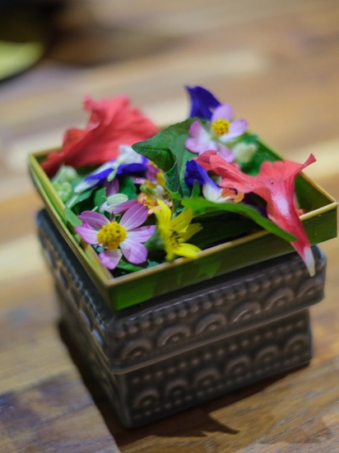

Picture 3.5.17. Canang Sari
(Personal Documentation,2019)

Inspired by one of the Balinese offering, Locavore has made an edible Canang Sari made out of various edible local flowers and edible local leaves. Served with Kecombrang Emulsion as a dipping sauce.

    - Monkey Business
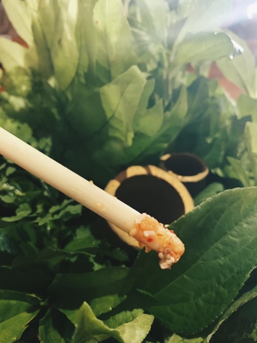

Picture 3.5.18. Monkey Business
(Personal Documentation, 2019)
As the second snack, Monkey business is filled with crumbles made out of chopped peanuts, sesame seeds, chopped crispy shallot, fresh edible flowers, fresh edible leaves and the one that keeps the guest surprised is that its filled with ant eggs, accompanied with black Sumba honey. The lemongrass stick is used as a spoon. It’s called monkey business because monkey use stick to hunt insect inside of the tree bark or hollow wood, and that’s where the inspiration comes from.
    - Black Rice Blini
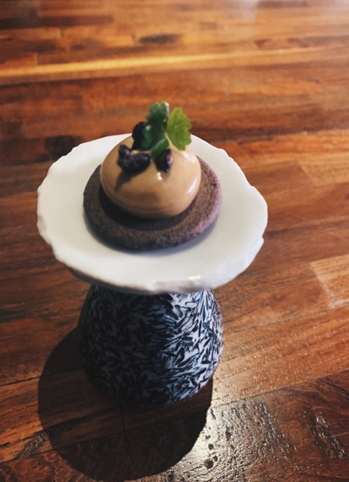

Picture 3.5.19. Black Rice Blini
(Personal Documentation, 2019)

Where blini known as Russian pancake that usually made from buckwheat but this time Locavore’s substitute with black rice flour, then on top there is smoked egg emulsion, black puffed rice and local leaves call Pegagan.
    - Frangipani Tempura
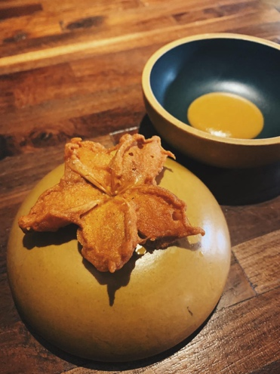

Picture 3.5.20. Frangipani Tempura
(Personal Documentation, 2019)

Fried edible local flowers, usually finds in the side walk all around Bali. Fried with tempura batter and served with pickle marigold emulsion.

    - Hot and Cold Tomato
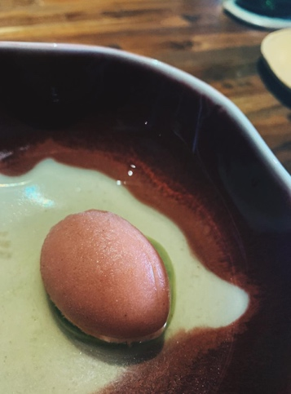

Picture 3.5.21. Hot and cold Tomato
(Personal Documentation, 2019)

One of Locavore’s signature dish, the amuse bouche as a palette cleanser before having the first course. The idea is to combine between hot and cold dish. There are slice tomato cherry on the bottom seasoning with celery salt, topped with tomato sambal sorbet that is a little bit spicy and finished with hot tomato consommé or clear tomato soup.
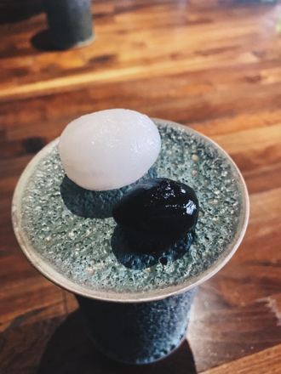
    - Old and New Rambutan

Picture 3.5.22. Old and New Rambutan
(Personal Documentation, 2019)

Using the method of making black garlic, leaving Rambutan for at least a week in a very low temperature, just until the color turns to black. The other Rambutan is fresh peeled before served.

    - Fermented Cassava Bread
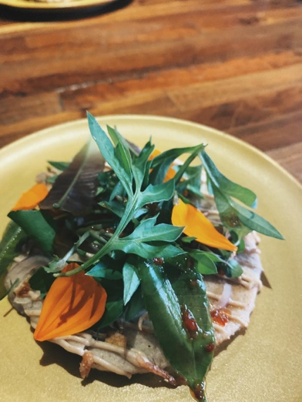

Picture 3.5.23. Fermented Cassava Bread
(Personal Documentation, 2019)

Served as a bread course, the bread is freshly made every day, using fermented cassava. Topped with smoked coconut sour cream, fresh local edible flowers and leaves, dressed with chili sesame dressings.

    - Yam Fries
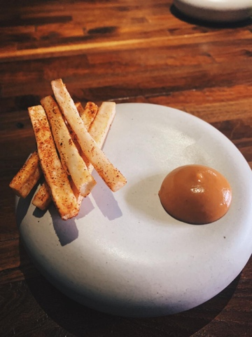

Picture 3.5.24. Yam Fries
(Personal Documentation, 2019)

Yam that's been cut into thin strips, fermented for 2 weeks. And then fried twice before serving. Sprinkled with Srirahca powder and homemade banana ketchup.

    - Prawn & Cucumber
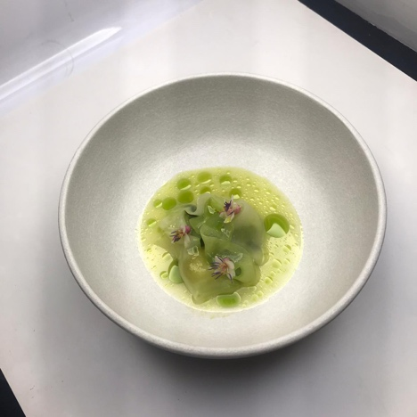

Picture 3.5.25. Prawn & Cucumber
(Personal Documentation, 2019)
First course in Locavore’s Wet Season Menu. Prawn that's been cured in sugar, served with green gazpacho and pickles of green tomato & cucumber seeds and flesh.

    - Lamb Curry Tartare
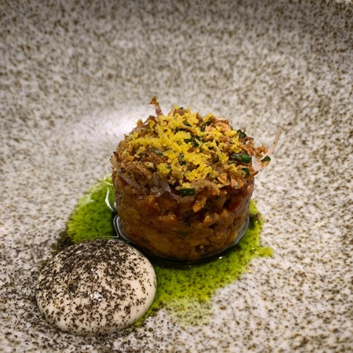

Picture 3.5.26. Lamb Curry Tartare
(Personal Documentation, 2019)

Second Course in Locavore’s Wet Season Menu. Minced lamb tartare that's been slightly grilled, seasoned with curry powder. Served with smoked yogurt, fried aromatics, cured egg yolk, smoked eggplant powder, and green chili oil.

    - Edi Broccoli
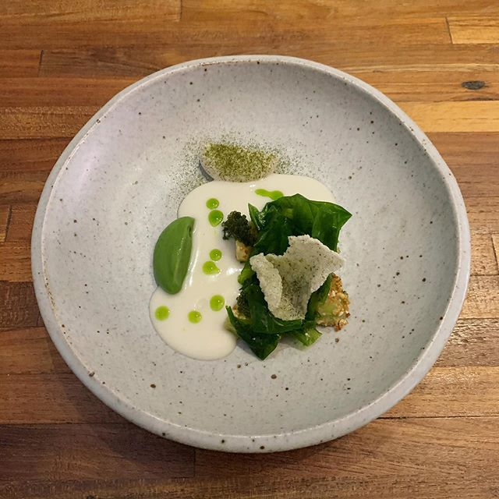

Picture 3.5.27. Edi Broccoli
(Personal Documentation, 2019)

Broccoli stems marinated in peanut miso served with broccoli ham puree, vichyssoise, chive oil, broccoli powder, broccoli crackers.

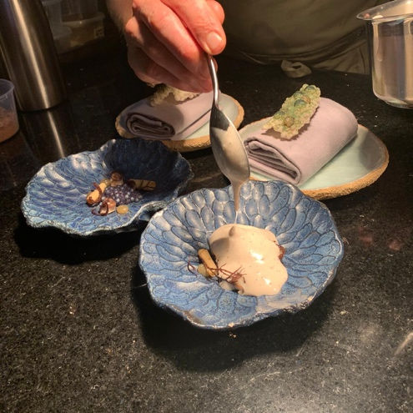
    - Sea Urchin

Picture 3.5.28. Sea Urchin
(Personal Documentation, 2019)

A dish that represent the taste of the sea, aromatic Jatiluwih rice served with pickled seaweed, spirulina miso vinaigrette and finished with sea urchin foam.

    - Lobster & Durian
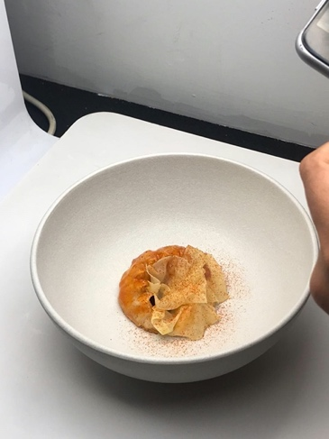

Picture 3.5.29. Lobster & Durian
(Personal Documentation, 2019)
An unique combination between lobster and durian, that turns out matched so well. Barbequed Lobster served with Sambal Tempoyak, charred fermented chili sauce and passionfruit pickled palm heart.

    - Chinese Cabbage
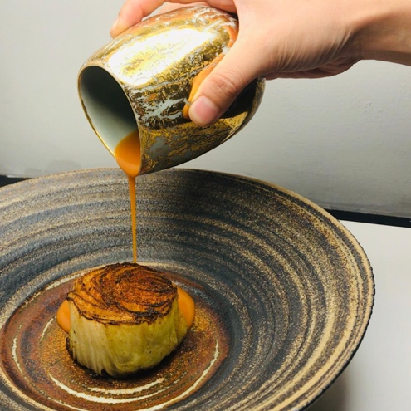

Picture 3.5.30. Chinese Cabbage
(Personal Documentation, 2019)

Cabbage roasted in smoked beef fat served with kimchi vinaigrette and aromatic X.O sauce.

    - Sweet and Sour Mango Sorbet
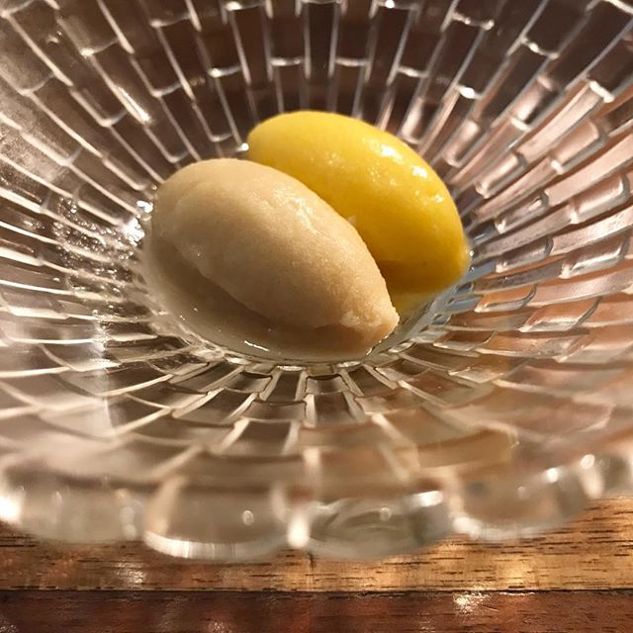

Picture 3.5.31. Sweet and Sour Mango Sorbet
(Personal Documentation, 2019)

2 different kinds of mango in a bowl, on the left is unripe mango sorbet which represent more acidic in taste, and on the right side is ripe mango sorbet which represent the sweetness.

    - Kue Boni
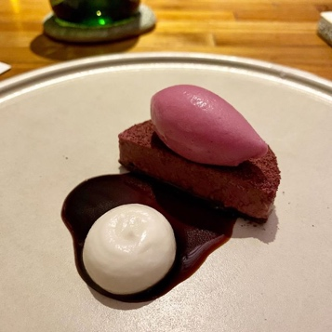

Picture 3.5.32. Kue Boni
(Personal Documentation, 2019)

Inspired by seasonal local berry from Bali, Boni or Blood berry has an attractive bright red colour and sweet acidic taste. Make into 3 ways, the first one is the blood berry tart itself with cacao nibs crust on the bottom, second the blood berry sorbet on top, third the blood berry syrup in the centre and egg whites coconut crème as a balance because the syrup is quite acidic.
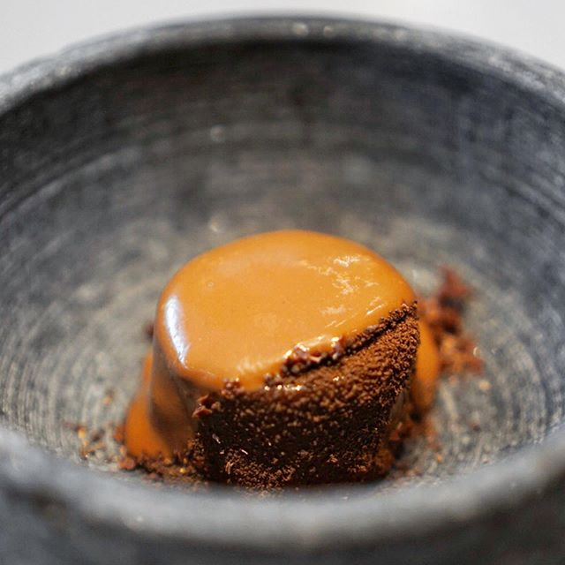
    - Bali Chocolate

Picture 3.5.33. Bali Chocolate
(Personal Documentation, 2019)

Using the finest local chocolate that taste bitter and sweet. Bali chocolate gelato, cacao butter cake, cacao nougatine, cacao crumble, finished with warm chocolate foam.

    - Congklak
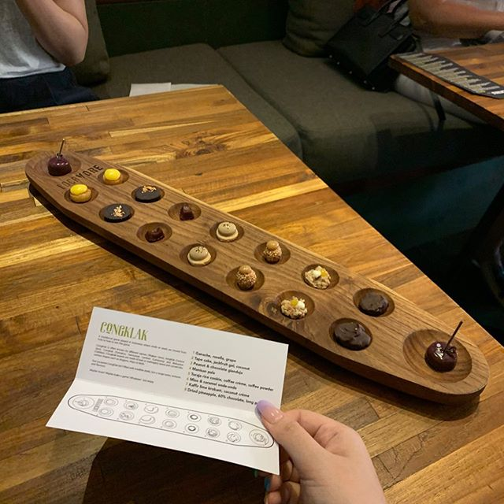

Picture 3.5.34. Congklak
(Personal Documentation, 2019)

Inspired by Indonesian traditional games, the concept of congklak board games has been used by Restaurant Locavore for years. Congklak will be filled by various types of Locavore’s sweets. Each person will get 8 different sweets: Tape goreng, pineapple chocolate, gianduja, krokant, coffee cookies, onde onde, and lollipop.
3.6. MENU

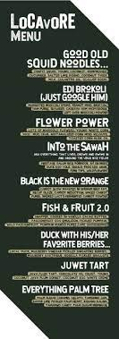

CHAPTER IV
CONCLUSION AND SUGGESTION

4.1. Conclusion
For the writer, internship program is a huge opportunity to have an experience working in real kitchen before entering the real workforce environment that was totally different from course study in collage. As a result after finished the internship program, the writer conclude that:
- The writer got a new experience on working in a real kitchen.
- The writer is responsible to work as a team.
- The writer is responsible to work under pressure.
- The writer is responsible to find solution and shortcut in precarious situation.
- The writer learns to manage time more effectively.
- The writer is responsible to work in limited space and time.
- The writer learns problem solving.
- The writer develops communication skill.
- Improve the knowledge about cooking techniques and local ingredients.
- Understands on standards high employee.
- Learn how to organize storage.
And last but not least the writer truly grateful for this internship are not only know what guest needs and want in culinary business but also something that makes guest attracted to come back. This internship gives benefit to all parties, not just the writer but also Restaurant Locavore and Ottimmo International Master Gourmet Academy.
- Suggestion
For upcoming trainee:
- Make sure to prepare mentally and physically.
- Whenever it feels like giving up, remember why u started.
- Every task that's been given will give knowledges.
- Further improving lessons, facilities, using more varied materials, teaching techniques that are more in line with the times.
For Restaurant Locavore:
Making a special place for pastry section might be a good idea, considering the heat from the hot kitchen in Locavore To Go is affecting the pastries.

REFERENCE

Anonymous. 2018. Restaurant Locavore – Ubud, Bali. https://www.baliaround.com/restaurant-locavore-ubud-bali/
accessed on 26 march 2020
Anonymous, 2019. Locavore.
https://www.locavore.co.id/about
accessed on 26 March 2020

APPENDIX

1. Pictures with the Guest

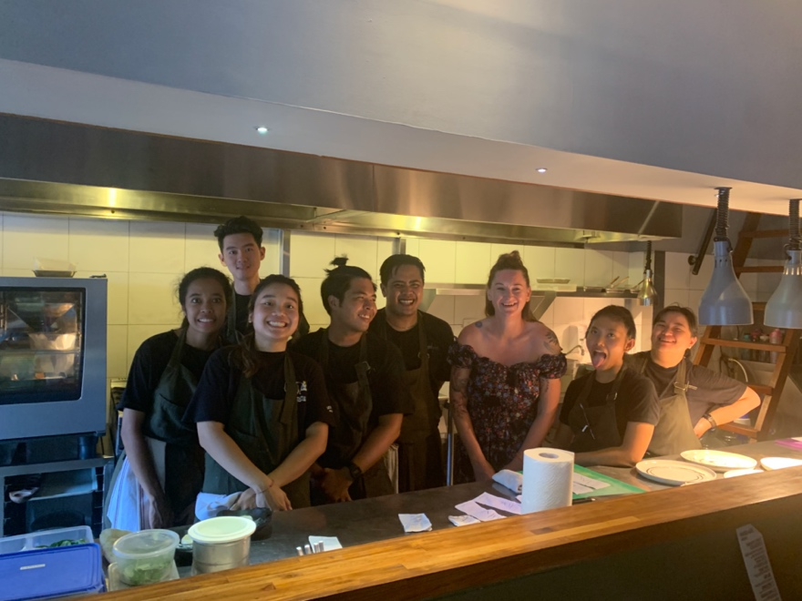
(Personal Documentation 2019)
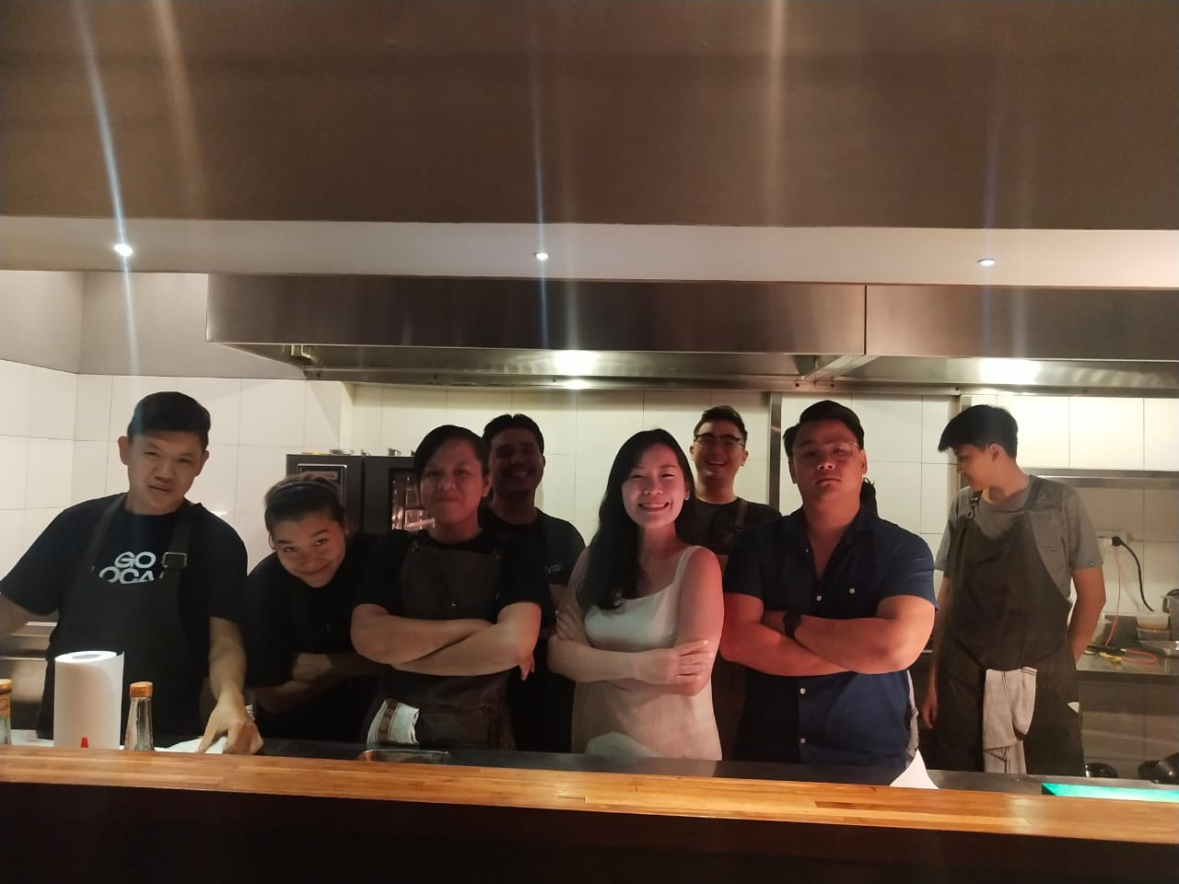

(Personal Documentation 2019)

2. Service Situation at Localab
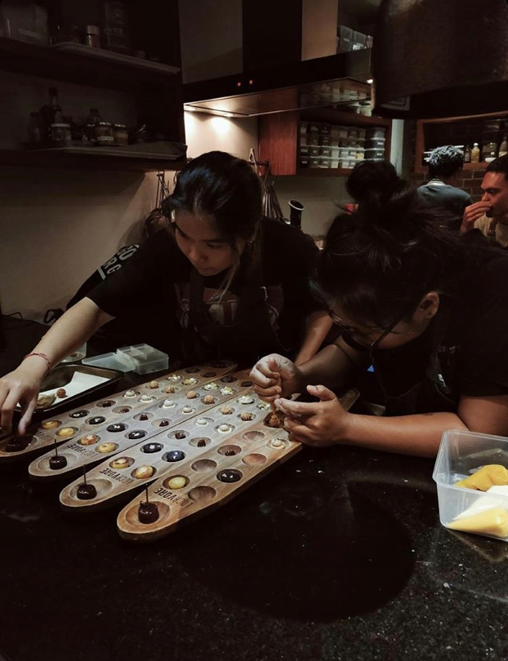

(Personal Documentation 2019)

