CHAPTER II

BUSINESS PLAN OVERVIEW

2.1 MARKET POTENTIAL

2.1.1 SEGMENTATION
For segmentation market has segmented its customer based on age, characteristic and behavior

2.1.2 TARGETING
Targeting sales to all people. Starting from the lower classes, middle and even upper classes. Because our products can be reached by all people at economical prices.

2.1.3 POSITIONING
In terms of positioning marketing, here we offer several different types of products than others, customers can order what variants they like. In the sense that customers are free to choose the variants they want. The price we offer can be reached by the customer in one portion of Mami Teh product.

2.2 LOCATION
Mami Teh is located in Jl. Gresik, Ruko Harbour Nine by Citinine, Krembangan, Surabaya. We are open on Monday – Saturday at 09.00 – 20.00.
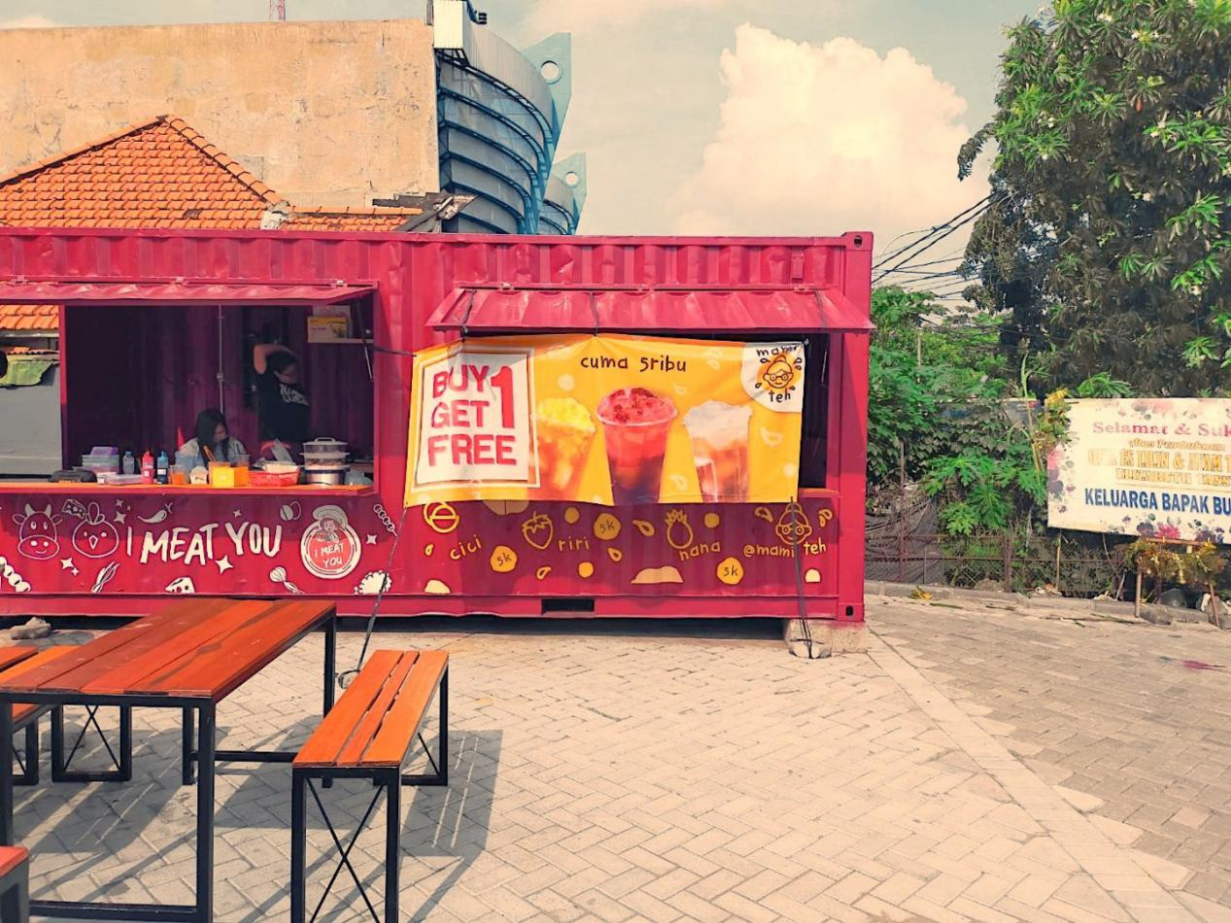
Picture 1. Mami Teh next to I Meat You

Picture 2. Map Location

2.3 PRODUCT & PRICE

There are three Mami Teh original’s recipes which are nana pineapple, riri strawberry, cici lychee. Premium tea is another masterpiece recipe that combine up to date flavour. Naming of Mami Teh menu is easy to pronounced and remembered. The price is also reasonable and reachable.

Picture 3. Menu

Picture 4. Best Seller Flavour Nana and Riri

2.4 SALES FORECASTING

As long as the sale has been running for approximately two months, we decide that every day we predict there are ten portion sold. That’s an estimate for the time being because we just opened.

2.5 MARKETING STRATEGIES

2.5.1 DISCOUNTS AND PROMOTION
• At the beginning, of the opening we had a promotion which was buy 1 premium tea get original tea for Rp10.000. we use banner promotion
• We also collaborate with several other foodpreneur, the promo that we offer is by paying only Rp13.000, has got 1 portion of pentol and 1 glass of ice tea

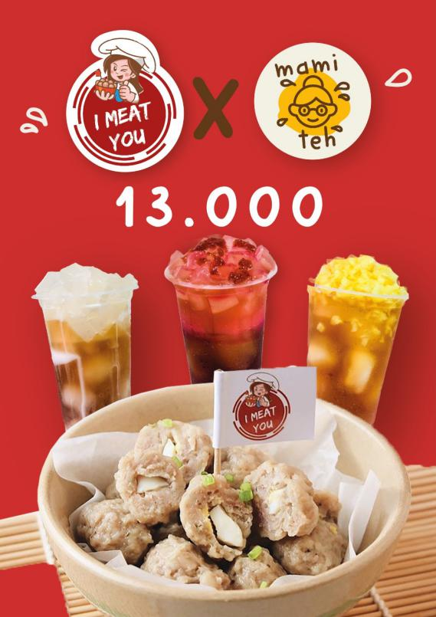
Picture 5. Mami Teh in collaboration with I Meat You

2.5.2 MARKETING

2.5.2.1 SOCIAL MEDIA
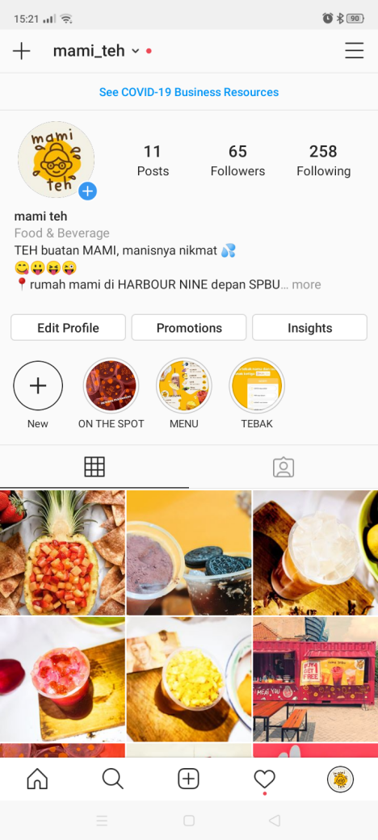
Picture 6. Mami Teh Instagram

To develop business , today social media plays an important role. Through social media we can tell everyone our products and our brand story , people will easily find and know our business. Through social media we can also interact with our customer so that we can tell promotions and new products. As well as what Mami Teh did, we circulate some of our opening info on Instagram, Line, WhatsApp, all other family , friends , and social media.

2.5.2.2 WORDS OF MOUTH
Words of mouth that has become familiar to us, one of the marketing that received the most attention also came from words to mouth.

2.6 SWOT ANALYSIS
STRENGHT
In terms of taste, the tea that I made with my own hands is guaranteed no doubt about it all. All people can taste my tea because the tea that I make are good combination. And the price that I offer can still be reached by lower and middle class people.

WEAKNESS
Because this is a new brand, so in terms of branding I have to be even more active in promoting and introducing this type of business.

OPPORTUNITY

Today’s society has been influence by the world of modernization which is everywhere looking for excitement or looking for something new especially in the culinary field. It can be seen as clear evidence that, today many young people are affected by boba drinks, which is a trend nowadays. So, if I make and design my street food business properly and correctly, it is no coincidence that the business that I founded can boom as well as old brands.

THREAT
There are tea sellers who first sell products with the same main ingredients.
Example Tong Tji

