INTERNSHIP REPORT
Internship Report at Sheraton Surabaya Hotel & Towers in ADD Section
“All Day Dining”

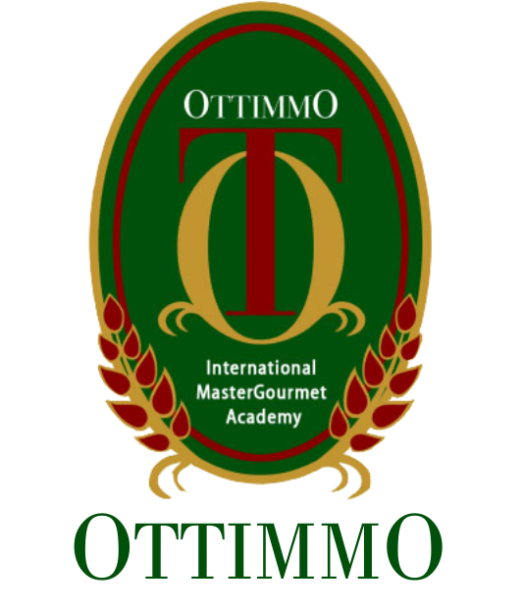

Arranged By:
Shania Salsabila
1774130010026

CULINARY ARTS STUDY PROGRAM
OTTIMMO INTERNATIONAL MASTERGOURMET ACADEMY
SURABAYA
2020

