CHAPTER II

GENERAL DESCRIPTION

OF HOTEL CIPUTRA WORLD SURABAYA

2.1 HISTORY OF COMPANY
Address : Jl. Mayjen sungkono No. 87 – 89,Surabaya, Jawa Timur, 60224.
Email : infocws@swiss-belhotel.com
Telephone : 0315120100
Website : www.hotelciputraworld.com
(http://www.hotelciputraworld.com/)
Hotel Ciputra world Surabaya or known as HCWS is one from Swiss-Belhotel five star hotel that located at Surabaya. Hotel Ciputra World Surabaya have a unique design because it have capsule structure and they have 22 floor. Hotel Ciputra World Surabaya can be say have strategy location because it located near the apartment and mall. Hotel Ciputra World is constructed around 2011 and get Formalized at 27 November 2014.
Strategically located adjacent Ciputra World Mall. the most urbane shopping mall in Surabaya. The hotel destined to become one of Surabaya signature landmark.
Providing a high quality of service with luxury facilities and personalized attentive service combined with mall and apartment, making Hotel Ciputra World Surabaya the preferred choice for discerning travelers, whether in Surabaya on business or leisure.
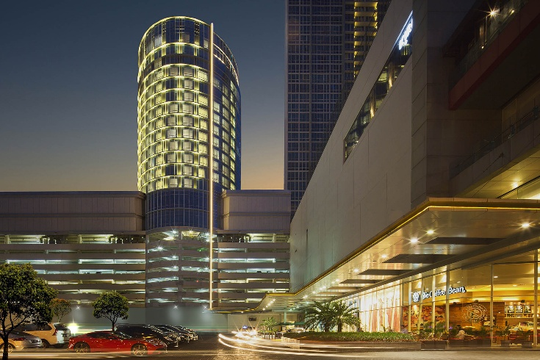
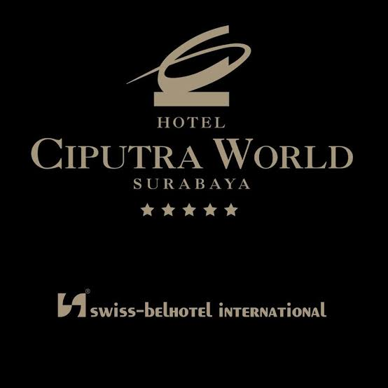
Picture 2 :Hotel Ciputra World (Hotel Ciputra World,2020)

Picture 1 : Logo Hotel Ciputra World (Hotel Ciputra World.,2020)

2.2 FACILITY
- Room Facility
Hotel Ciputra World Surabaya have 22 floor in total of 212 room that have many type:
- Deluxe room
- Superior Deluxe Room
- Grand Deluxe Room
- Suite Room
- Meeting Room Facility
- Glory Meeting Room
Located at 7th floor and total of 5 room that used to meeting room. With a elegant design and modern meeting facility the room it self can get filled to 74 People in 1 room.
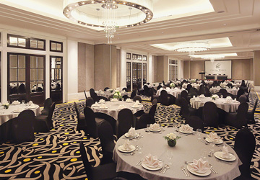
- Victory Room
Located at 8th floor with elegant and elite design. This have a total of 3 room that can be used as a ballroom. Used to confrence , meeting , party , and etc. It can filled with 150 to 450 depend on the setup that used.
Picture 3 : Victory Room(Hotel Ciputra World,2020)

- Restaurant Facility
- The Gallery Restaurant
Located at 7th floor with artistic design that give people chilled atmosphere when eating. Provide buffet menu or ala carte that customer wanted. Open at 06.00 WIB – 23.00 WIB.
- The Lounge
Located at 8th floor with more fancy than Gallery this lounge tend to be used for bussiness man or someone that dont want loud noise when they eat. Customer can order Tea, Coffee, Wine, Cocktail, Mocktail, and Snack to chill. Open at 06.00 WIB – 23.00 WIB.
- Executive Lounge
Located at 22th floor and located at the top of Hotel Ciputra World. Can be used as chill and meeting placed. Its located near Pool, Gymnasium, and Spam. Customer can order some food to from Gallery. Open at 18.00- 20.00 WIB.
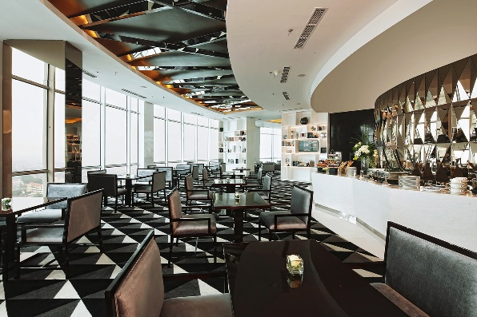
Picture 4 : Executive Lounge (Hotel Ciputra World,2020)

- Other Facility
- Pool
- Spa
- Gymnasium
- Room Service 24 Hours
- Security and CCTV 24 Hours
- Mall
- Wifi
- Smoking Area, and Etc.
  - VISION AND MISSION
Vision
Developing a property business group with a spirit of excellence and full of innovation, thus creating added value in providing a better life for the community and providing prosperity and prosperity for stakeholders.
Mission
To be at the forefront of the property business by being the most superior, professional and profitable, so that it becomes the first choice for consumers, the most attractive and challenging workplace for employees, the most profitable investment for shareholders and the most blessing real for the people and the country.
- About Kitchen
For the kitchen we have hot kitchen, cold kitchen, steward, and chiller room. For hot kitchen its spilt into two department, one for western section and second one is for asean section. Cold kitchen is for pastry or bakery and Garde Mager. 2 steward section, one is in the front where the kitchen entrance and second one in back of the kitchen. In chiller room is just one big chiller that fill with ingredients and inside there is door that go to freezer usually its fot ala carte main ingredients, pastry, and bakery. In every section there is 1 chiller for ala carte from hot kitchen to cold kitchen. In the middle of asean and western section there is ala carte section. It used for plating for ala carte and final dish plating.

2.4 ORGANIZATION STRUCTURE
GDM
Supervisor
Commi 3
Trainee

Commi 1
Trainee

Commi 3
Commi 2
Commi 3
Commis 3
Trainee
Butcher Commi 1

Commi 3
Commi 3
Daily worker
CDP Asean
CDP Westren
Pastry Chef
Sous Chef
Executive Chef

CDP Bakery

Daily worker
Daily Worker

Commi 3
Commi 2
Daily Worker

Trainee
Daily Worker

Daily Worker
Daily Worker
Daily Worker

JOB DESK
- Executive Chef
Executive Chef doesn't mean he cooks the most. His job is to create menu as well as the costs incurred, overseeing all kitchen work, including ensuring food processing in accordance with established standards. If there are complaints from customer, the Head Chef will also advance to handle it, basically monitoring kitchen and customer complaints or suggestion.
- Sous Chef
The second person on charge when Executive Chef is cant attend and in addition arranging schedule for Executive Chef. Chef de Cuisine also responsible for all decision made in kitchen when Executive Chef unable to attend.
- Pastry Chef
Chef that responsible to pastry and bakery department that work under Executive Chef and Sous Chef. All decision made need to report to Executive Chef or Sous Chef.
- Chef de Partie Western
Take all control of Western section, maintaining food and processing procedure for Western food. Chef de Partie also work under Executive Chef and Sous Chef.
- Chef de Partie Asean
Same like Western, Chef de Partie Asean also maintaining food and processing food and report to Executive Chef or Sous Chef.
- Chef de Partie Bakery
Unlike the two Chef de Partie, Bakery work baking only and report the work to Chef Pastry, from then Chef Pastry report it to Executive Chef or Sous Chef.
- Commis
These are workers that assist with task within the kitchen, and are less likely to have any formal culinary training. Task including basic food preparation such as washing salad, peeling potato, cleaning duties depend on their department.
- Daily Worker
Worker that use daily basis work. Usually it get called to came for work especially when the hotel is busy on event.
- Trainee
Student that intern to take a training under guidance of senior.
- Butcher
Butcher work is cut meat for western and asean food. Butcher also responsible to order ingredients to Executive Chef.
- Garde Manger
Garde Manger work in cold station. Usually prepare salad vegetables, and any kind of fruits.
- Supervisor
Supervisor is the head of cleaning. They work like maintaining sanitation about all glassware and floor cleaning. They work with daily worker to clean the kitchen.

