**INTERNSHIP FINAL REPORT**

**HOTEL CIPUTRA WORLD**

**NAME : JONATHAN GUNAWAN**

**NIM : 1774130010051**

**CULINARY ARTS STUDY PROGRAM**

**OTTIMMO INTERNATIONAL MASTERGOURMET ACADEMY**

**SURABAYA**

**2020**

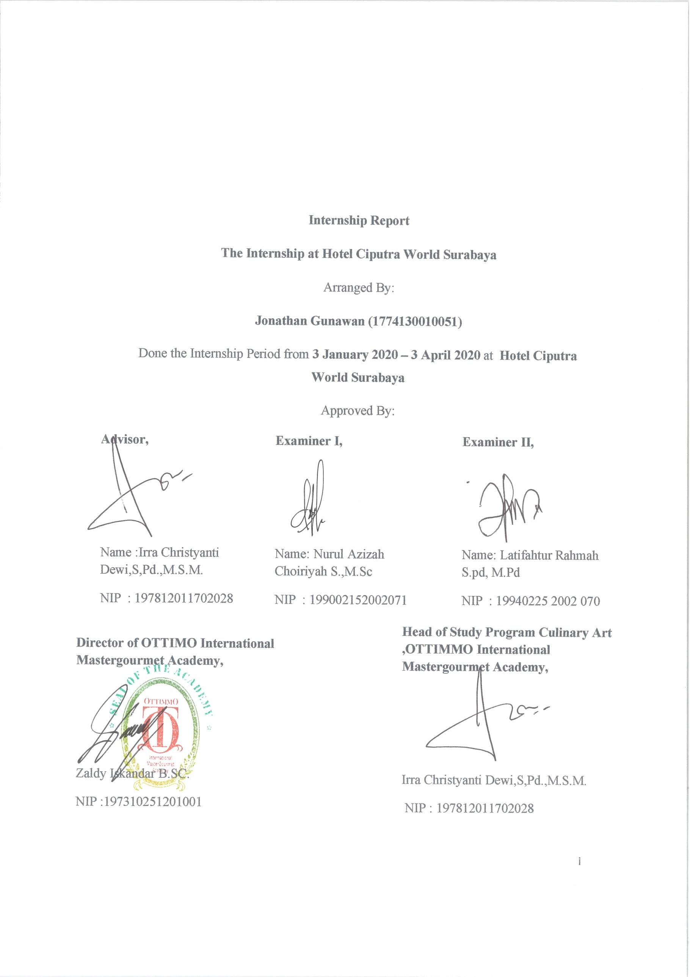

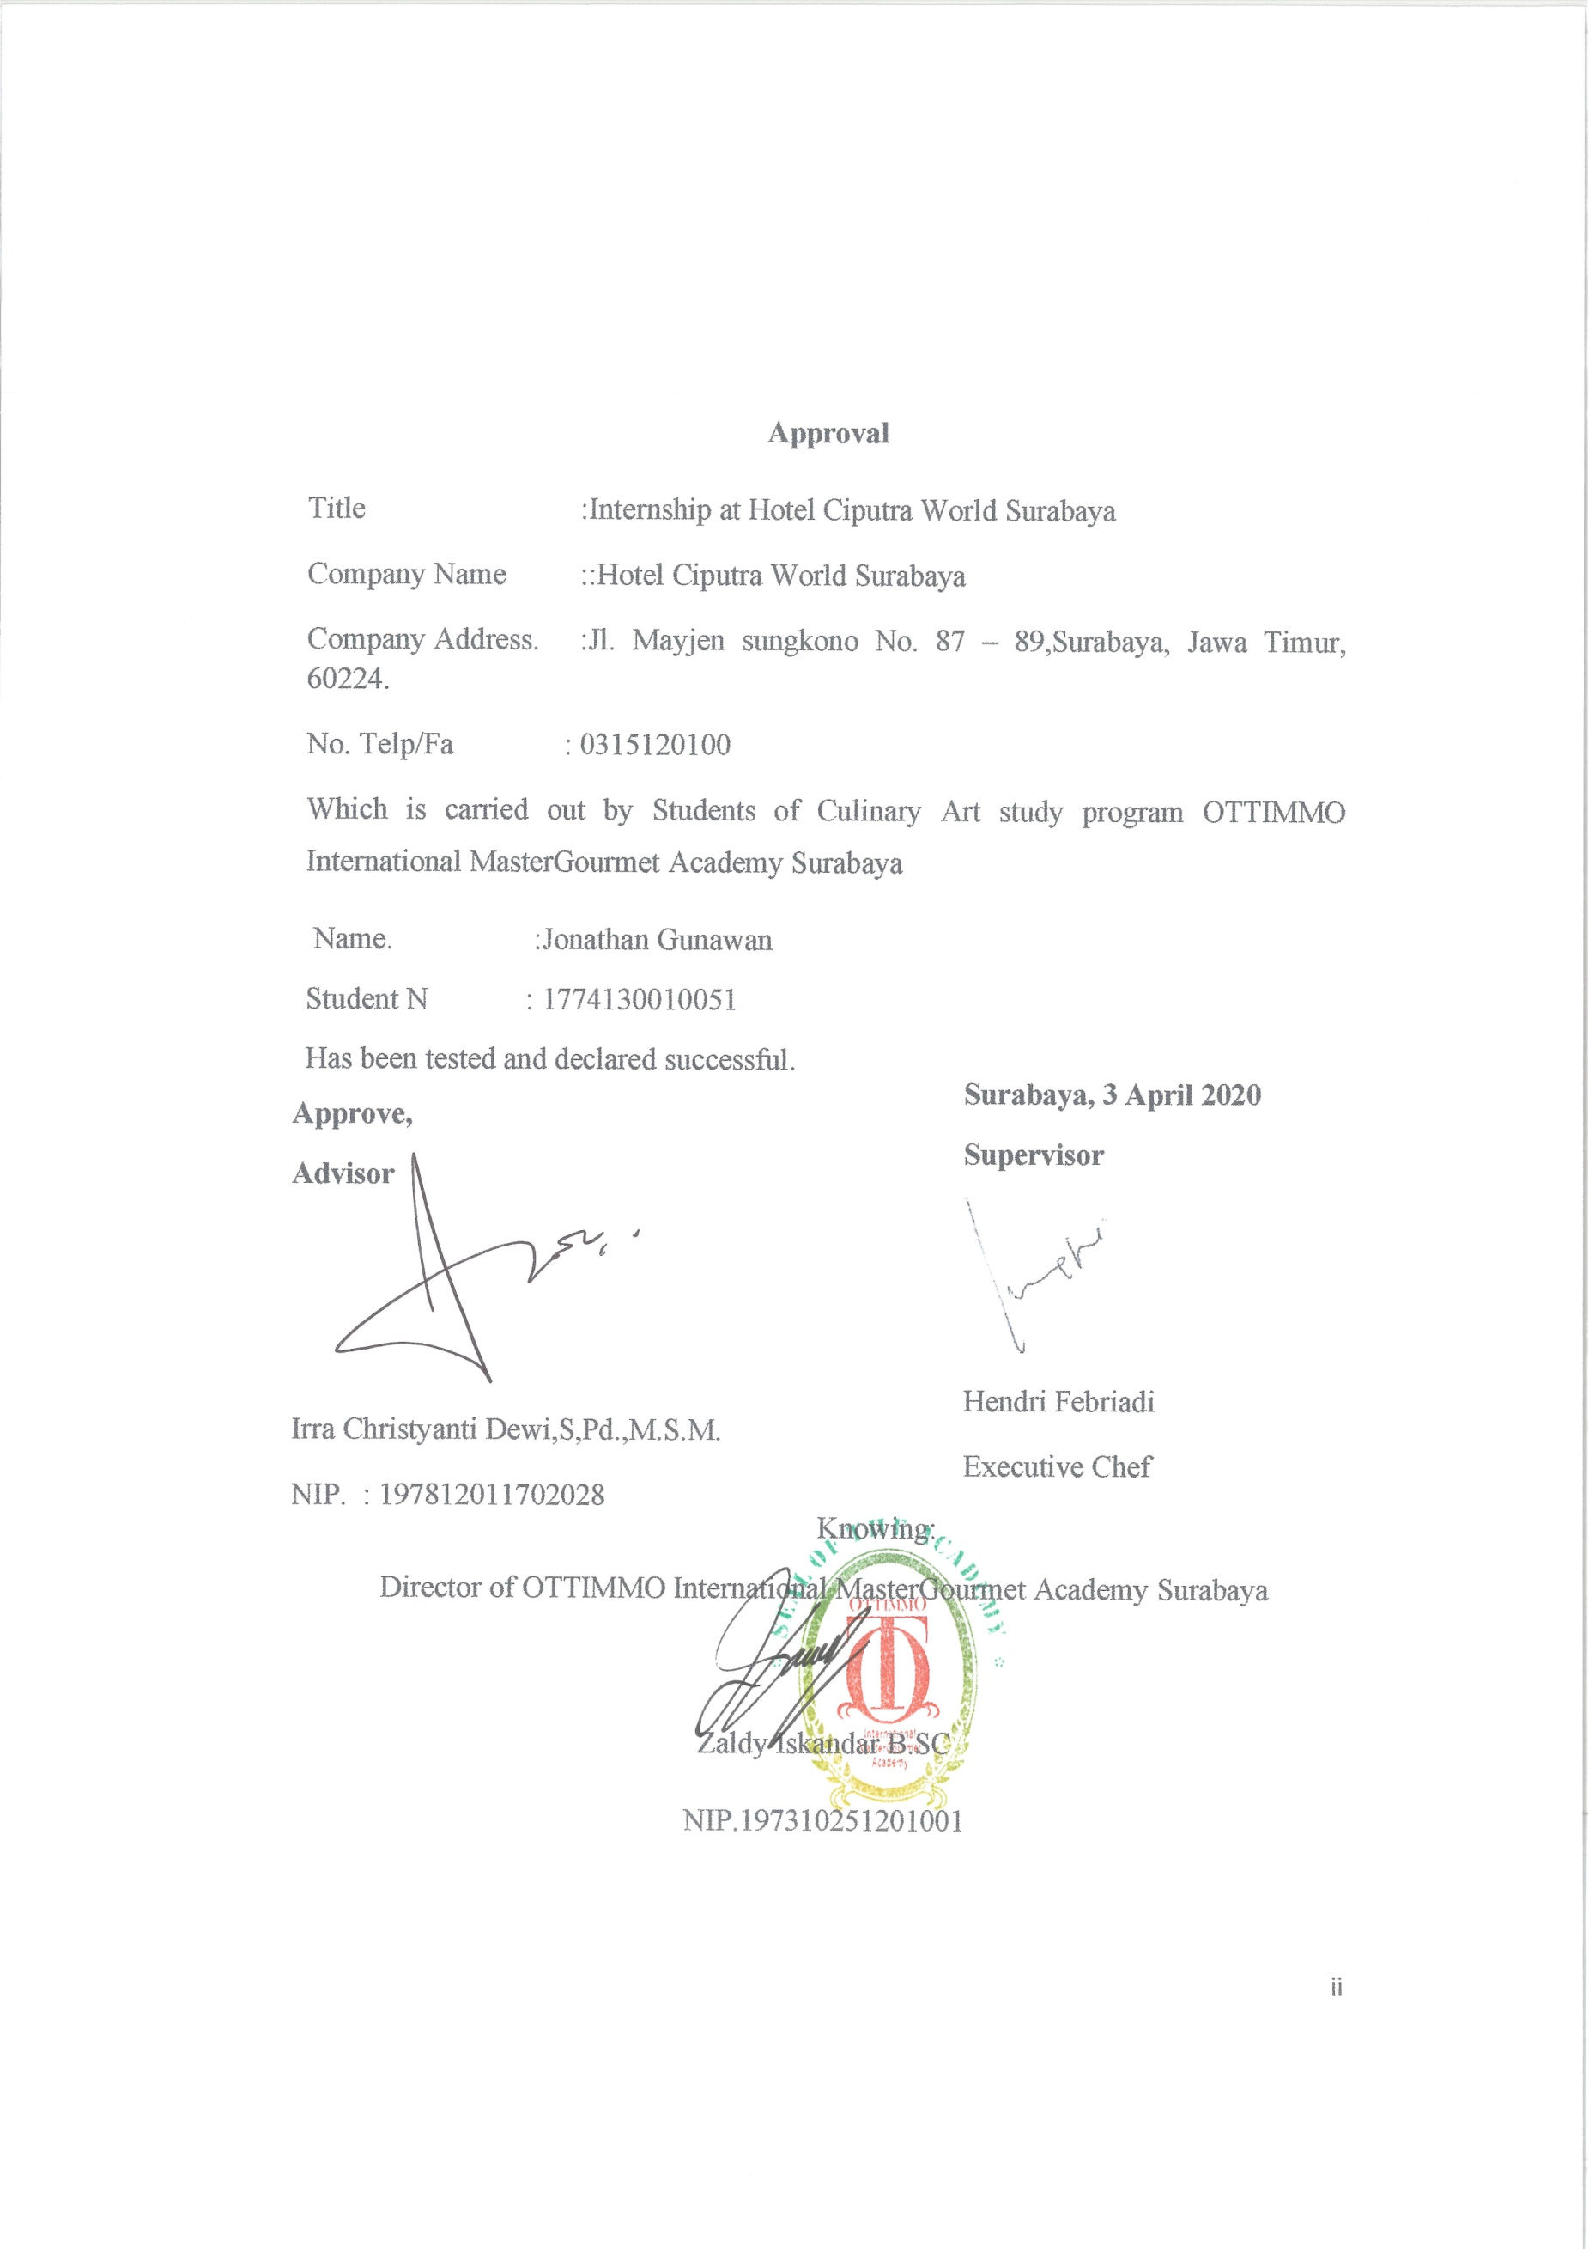

**ACKNOWLEDGMENT**

At First, I want to thanks to God that help me and bless me to complete this report. This report is prepared based on Internship result conducted by the Authors during 3 months in Hotel Ciputra World. This report is prepared to complete the Diploma III of Culinary Arts.In the process of completion of this report, the Author has received much guidance and assistance from various parties. To that end, the authors express their sincere thanks to

1. Miss Irra as Advisor who has guided, provide guidance and suggestions until the completion of this report.
2. Chef Zaldy Iskandar, B.Sc as Director of Akademi Kuliner dan Patiseri OTTIMMO and Miss Irra Chrisyanti Dewi, S.Pd., M.S.M as Head of Study Program of Akademi Kuliner dan Patiseri Ottimmo Internasional
3. Other participant who wish to be reffered to as parents.

I hope that this report will be useful for everyone.

Surabaya, 3rd April 2020

Jonathan Gunawan

**PLAGIARISM STATEMENT**

I certify that this assignment/report is my own work, based on my personal study and research and that I have acknowledged all material and sources used in its preparation, whether they be books, articles, reports, lecture notes, and any other kind of document, electronic or personal communication. I also certify that this assignment/ report has not previously been submitted for assessment in any other unit, except where specific permission has been granted from all unit coordinators involved, or at any other time in this unit, and that I have not copied in part or whole or otherwise plagiarized the work of other students and /or person.

On this statement, I am ready to bear the risk/ any sanctions imposed to me in accordance with applicable regulations, if in the future there is a breach of scientific ethics, or you have a claim against the authenticity of my work.

Surabaya, 3rd April 2020

Jonathan Gunawan

**TABLE OF CONTENTS**

COVER

APPROVAL i

APPROVAL INTERNSHIPii

ACKNOWLEDGMENT iii

PLAGIARISM STATEMENTiv

TABLE OF CONTENTS v

LIST OF PICTUREvii

LIST OF TABLE viii

EXECUTIVE SUMMARYix

*CHAPTER I* INTRODUCTION1

BACKGROUND 1

OBJECTIVE 2

THE BENEFIT OF INTERNSHIP 2

*CHAPTER II* GENERAL DESCRIPTION 3

HISTORY OF COMPANY3

FACILITIES4

VISION AND MISSION6

ORGANIZATION STRUCUTRE8

*CHAPTER III* INDUSTRIAL TRAINING ACTIVITIES11

PLACE OF ASSIGNMENT11

ACTIVITIES11

PRODUCT OF INTERNSHIP13

HYGINE AND SANITAZION14

PROBLEM AND SOLVE15

*CHAPTER IV* CONCLUSION 17

*APENDIX* 18

**LIST OF PICTURE**

PICTURE 1 4

PICTURE 24

PICTURE 35

PICTURE 46

PICTURE 518

PICTURE 618

PICTURE 718

PICTURE 818

PICTURE 919

PICTURE 1019

PICTURE 1119

PICTURE 1219

PICTURE 1319

PICTURE 1419

PICTURE 1513

PICTURE 1614

**LIST OF TABLE**

TABLE 111

**EXECUTIVE SUMMARY**

“Internships” are needed by students to master certain skills or expertise. Besides that, it is the main requirement for completing the education process. Under the guidance from Supervisor and Senior writer learn a method from them. So writer intern it from January 3rd, 2020 until April 3rd, 2020.

Writer am an intern at Hotel Ciputra World - Surabaya. Hotel Ciputra World its a five star hotel that provide customer with a good hospitalty and service that make customer satisfy with Hotel service.

Many experiences that writer got there. At first writer was trained to Clean everything, after that writer learn how to prepared condiments, cutting skills, and sorting ingredients. And not only that, but writer was trained how to serve customers well and politely. From there writtler learn how to work fast and always polite, using the right grammar for greetings Customer or Supervisor, and more importanly how to work as a Team.

Keyword: Hotel Ciputra World Surabaya, Western, Internship